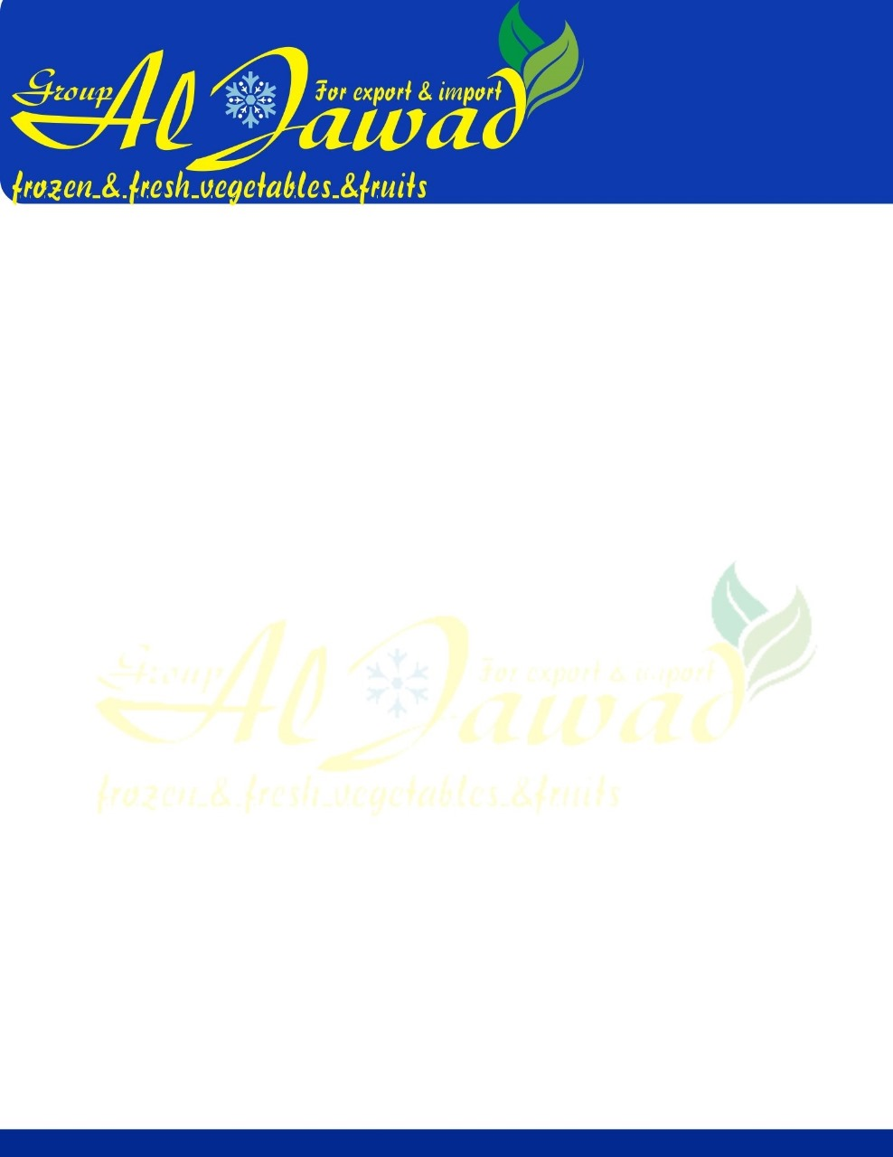

**Frozen Artickoke Buttom**

|  |  |  |  |  |
| --- | --- | --- | --- | --- |
| **1. Description** |  |  |  |  |
|  |  |  |  |  |
| Product description | IQF artichoke bottoms | |  |  |
| Process description | The artichokes are washed, sorted, blanched, individually quick-frozen, resorted and packed. | | | |
| Latin name | *Cynara scolymus* |  |  |  |
| Composition | *size* | *%* | *geographic origin* | |
| artichoke bottoms | Ø 50-70 mm | 100% | Egypt | |
| Legal name | Quick-frozen artichoke bottoms | | |  |
| Vegetarian/vegan information | The product is suitable for vegetarians and vegans. | | | |
| **2. Microbiological standards (cfu/g)** |  | | | |
|  | MAXIMUM | | | |
| Total aerobic mesophile plate count | 500.000 | | | |
| E. coli | 100 | | | |
| Yeast and moulds | 10.000 | | | |
| Coagulase-positive Staphylococci | 100 | | | |
| Listeria monocytogenes | 10 | | | |
| Salmonella spp. | absent/25g | | | |
| **3. Chemical standards** | | | | |
| Heat treatment | blanched | | | |
| pH | 4,8 - 5 | | | |
| Pesticides | in accordance with EC regulation 396/2005 and its  modifications | | | |
| Heavy metals, mycotoxins and nitrates | in accordance with EC regulation 1881/2006 and its  modifications | | | |
| GMO | the product is free from gmo, according to the EC  regulations 1829/2003 and 1830/2003 and its modifications | | | |
| Radiation | the product is not irradiated | | | |
| **4. Sensorial standards** | | | | |
| Per 200 g (prepared) | | | | |
| Colour | uniform light greyish colour | | | |
| Flavour/Odour1 | characteristic of artichokes, no off flavours/odours | | | |
| Texture | tender, not fibrous | | | |



# Average nutritional values

|  |  |  |  |  |  |
| --- | --- | --- | --- | --- | --- |
|  | **per 100 g** |  | **unit** | **% RI* per**  **100 g** | **RI\*** |
| Energy | 124 |  | kJ | 1% | 8400 |
| Energy | 30 |  | kcal | 1% | 2000 |
| Fat | 0,5 |  | g | 1% | 70 |
| of which saturates | 0,20 |  | g | 1% | 20 |
| Carbohydrate | 1,9 |  | g | 1% | 260 |
| of which sugars | 1,9 |  | g | 2% | 90 |
| Fibre | 4,9 |  | g | - | - |
| Protein | 2,0 |  | g | 4% | 50 |
| Salt | 0,45 |  | g | 7% | 6 |

|  |  |
| --- | --- |
| Source | Analysis on product as sold |

*Reference intake of an average adult (8400 kJ / 2000 kcal)

# Allergen information

|  |  |  |  |
| --- | --- | --- | --- |
| **Allergens according to the EU Regulation 1169/2011 and its modifications:** | | | |
|  | Product contains (+) or is free from  (-) | Present (+) or absent (-) on site | Present (+) or absent (-  ) on the same line |
| Cereals containing gluten, namely: wheat, rye, barley, oats, spelt, kamut or their hybridised strains, and products thereof; except: 1/ wheat based glucose syrups including dextrose, 2/ wheat based maltodextrins, 3/ glucose syrups based on barley, 4/ cereals used for making alcoholic distillates including ethyl alcohol of agricultural origin. | - | + | - |
| crustaceans and products thereof | - | + | - |
| eggs and products thereof | - | + | - |
| fish and products thereof; except: 1/ fish gelatine used as carrier for vitamin or carotenoid preparations, 2/ fish gelatine or Isinglass used as fining agent in beer and wine | - | + | - |
| peanuts and products thereof | - | - | - |
| soybeans and products thereof; except: 1/ fully refined soybean oil and fat, 2/ natural mixed tocopherols (E306), natural D- alpha tocopherol, natural D-alpha tocopherol acetate, natural D- alpha tocopherol succinate from soybean sources, 3/ vegetable oils derived phytosterols and phytosterol esters from soybeans sources, 4/ plant stanol ester produced from vegetable oil sterols from soybean sources | - | + | +* |
| milk and products thereof (including lactose); except: 1/  whey used for making alcoholic distillates including ethyl alcohol of agricultural origin, 2/ lactitol | - | + | - |



|  |  |  |  |
| --- | --- | --- | --- |
| nuts i.e. almonds, hazelnuts, walnuts, cashews, pecan nuts, brazil nuts, pistachio nuts, macadamia nuts and queensland nuts and products thereof; except: nuts used for making alcoholic distillates including ethyl alcohol of agricultural origin | - | - | - |
| celery and products thereof | - | + | +* |
| mustard and products thereof | - | + | - |
| sesame seeds and products thereof | - | - | - |
| sulphur dioxide and sulphites at concentrations of  more than 10 mg/kg or 10 mg/litre expressed as SO2 | - | + | - |
| lupin and products thereof | - | - | - |
| molluscs and products thereof | - | + | - |
| **Other allergens (according to LeDa-list):** | | | |
| Beef | - | + | - |
| Pork | - | + | - |
| Chicken | - | + | - |
| Corn/Maize | - | + | +* |
| Cacao | - | - | - |
| Legumes/pulses | - | + | +* |
| Glutamate | - | + | - |
| Coriander | - | + | +* |
| Carrot | - | + | +* |

*presence on the same production and/or packing line(s), but no cross contamination as a result of preventive measures (based on our HACCP risk assessment)

# Definitions of defects

* 1. Foreign material

This includes any non-vegetable material like insects, wood, glass, stones, metal, snails, etc.; and toxic vegetable material.

* 1. Foreign extraneous vegetable matter (FEVM)

This includes any vegetable matter, not derived from the artichoke plant, such as weed, leaves, etc.; except toxic vegetable material.

* 1. Extraneous vegetable matter (EVM)

This includes any vegetable material which is derived from the artichoke plant, but foreign to the product; such as pieces of leaf, stalks, etc.



* 1. Major blemishes

This includes dark blemishes > 10 mm.

* 1. Minor blemishes

This includes dark blemishes < 10 mm.

* 1. Stalks

This includes pieces with stalks > 2 mm.

* 1. Fibrous bottoms
  2. Flat bottoms or exocentric bottom
  3. Major bottom splits

This includes pieces which possess splits > radius of bottom.

* 1. Minor bottom splits

This includes pieces which possess splits < radius of bottom.

* 1. Major damaged bottoms

This includes pieces of which parts > 2 cm³ are missing.

* 1. Minor damaged bottoms

This includes pieces of which parts < 2 cm³ are missing.

* 1. Clumps

This includes pieces which are welded together (more than 2 pieces stuck together).

* 1. Out of calibration

This includes pieces with a diameter < 50 mm or > 70 mm.

8-Defects:



|  |  |  |
| --- | --- | --- |
| DEFECTS | TARGET | MAXIMUM |
| Per 1000 g (frozen) | | |
| a) Foreign material (number) | 0 | 0 |
| b) FEVM (number) | 0 | 0 |
| c) EVM (number) | ≤ 2 | 4 |
| d) Major blemishes (number) | ≤ 1 | 2 |
| e) Minor blemishes (number) | ≤ 3 | 6 |
| f) Stalks (number) | ≤ 3 | 6 |
| g) Fibrous bottoms (number) | ≤ 1 | 2 |
| h) Flat or exocentric bottoms (number) | ≤ 2 | 4 |
| i) Major bottom splits (number) | ≤ 2 | 4 |
| j) Minor bottom splits (number) | ≤ 5 | 10 |
| k) Major damaged bottoms (number) | ≤ 1 | 2 |
| l) Minor damaged bottoms (number) | ≤ 3 | 6 |
| m) Clumps (number) | ≤ 2 | 4 |
| n) Out of calibration (% by weight) | ≤ 10% | 20% |

1. **Packaging**

Standard packaging options

|  |  |  |
| --- | --- | --- |
| RETAIL PACKAGING | | |
| Net weight | 500 g up to 2500 g | |
| Packaging | PE bag / consumer carton box | |
|  | heat sealed / sealed + easy open / sealed + topzip | |
| Pallet | euro / industry pallet | |
| INDUSTRY PACKAGING | | |
| Net weight | 3 kg up to 18 kg | carton + PE bag |
|  | 15 kg - 20 kg - 25 kg | PE bag |
|  | octabins / ½ octabin | |
| Pallet | euro / industry pallet | |



All packaging materials are Food Grade (according to current European legislation). The packaging and pallet layout should be agreed with the Dujardin Sales Department. Alternative packaging options can be discussed.

|  |  |
| --- | --- |
| Lot number | L. LLL BB YDDD; LLL = packing line, BB = batch, Y  = year, DDD = day of the year of packing (consumer packs) / See packaging (bulk product) |
| Best Before | 24 months from packing (max. 48 months from  freezing) |
| Storage conditions | -18°C |

# Cooking instructions

Cook from frozen. Prepare as fresh vegetables with reduced cooking time. Ensure the product is piping hot before serving. Add spices to your own taste.

Do not refreeze after defrosting.

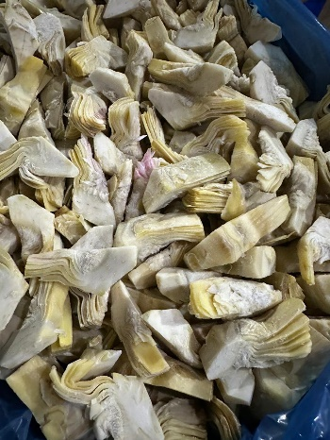

# Picture

