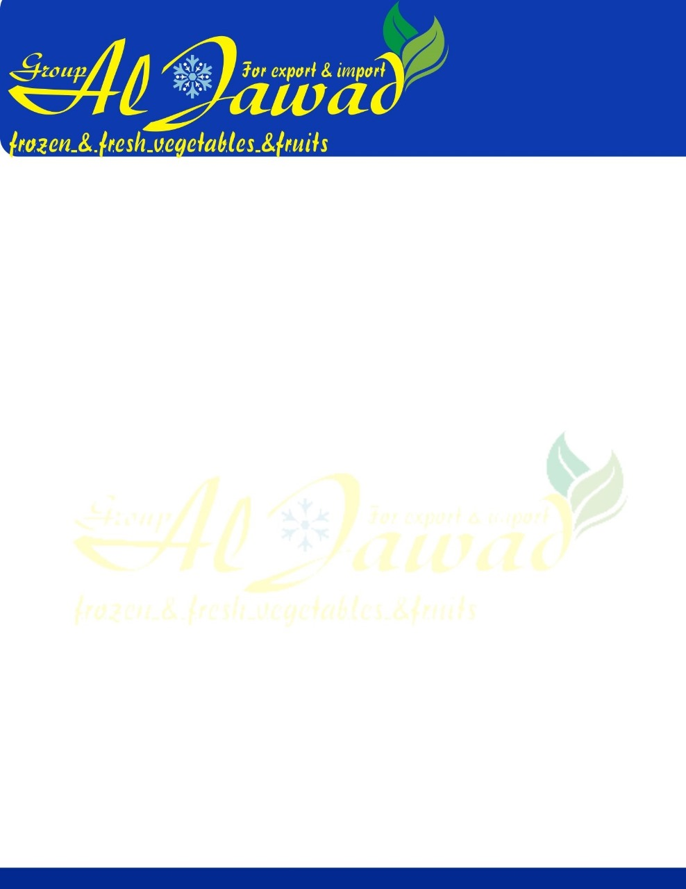

**Egyptian Green Beans**

**Botanical Name: Phaseolus vulgaris  
Origin: Egypt  
Availability of Egyptian Green Beans: November to February – June to September**

**Packing:.**

**Packing available:  
400 GM , 800 GM in 8 KG carton  
4 * 2.5Kg bags in 10 KG carton**

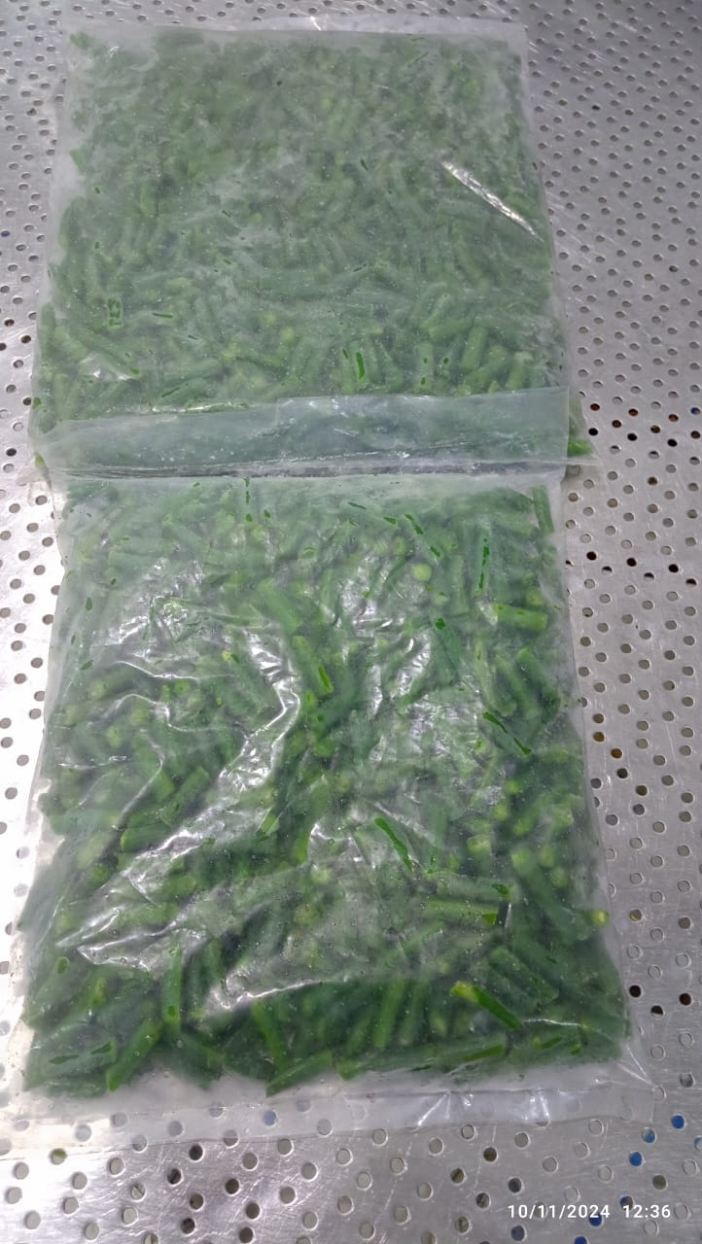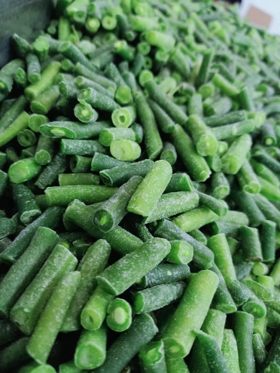**10KG Bulk Packing   
Container Capacity:  
40 ft container takes 22 MT.  
Lead time: 2- 3 weeks  
Product shelf life: 4 Months**