

**Certificate of analyses**

**Brand: AlJawad Group**

**Size: (1×10kg. /4 X 2.5 kg.)**

**Photo for product:**

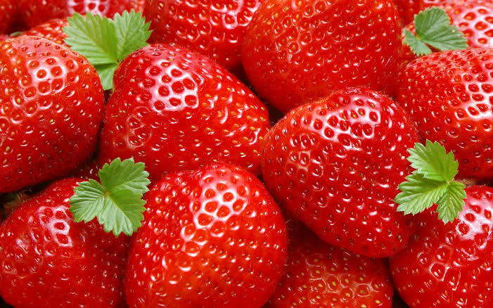

|  |
| --- |
|  |
| 31-Product Description Strawberries traditional cut quick-frozen.  2-Size: 10*3 – 2.5*3 – 1.5*2 cm  3-Process description: This product is made of Strawberries which are washed, sorted , quick frozen and packed.  4- Strawberries - Comment: The processed Strawberries are purchased from approved suppliers who meet local laws and regulations standard  5-Brand: AlJawad  6-SKU-No.: |



|  |
| --- |
| 1. INGREDIENTS : |
| 1. Strawberries : 100 % |
| 1. Quality Parameters :  |  |  |  |  |  |  |  | | --- | --- | --- | --- | --- | --- | --- | |  |  |  | Green | Amber | Red | Comment | | Grading | **Size & Berry count (minimum number of berries per punnet)** | **% W/W** | **<3% outside 27 to 45mm 227g- 7 berries 400g- 12 berries** | **3 to 5% berries outside the size band** | **>5% berries outside the size band <7 berries on 227 & <12 berries on 400g** |  | | Breakage |  | **% W/W** | **1%** | **1.5%** | **2%** |  | | Defects units |  | **du/kg** | **1** | **1** | **2** |  | |  | **%** |  | **1%** | **2%** | **3%** |  |   Key: Defect-units: Sum of points for all pieces with minor, major and gross defects for sample of 1000 g.  1-Minor defect: (3cm) = 1point  2-Major defect: (2-2.5cm) = 2 points  3-Critical defect: ( 1-2cm) = 3 points | |
| 1. Chemical Properties: | |
| |  |  |  |  | | --- | --- | --- | --- | |  | Min. Target | Maximum |  | | Moisture content % | 67% 72% | 74 % |  |  1. Microbiological Properties: (CFU/ G.)  |  |  |  |  | | --- | --- | --- | --- | | Parameter | Test Method | Target/ CFU/mg | Maximum | | Total Plate Count | ISO- 4833:2013 | <10 4 CFU/mg | <10 4 CFU/mg | | Yeast | ISO-21527-1:2008 | Less than 50 | Less than 50 | | Mould | ISO-21527-1:2008 | Less than 50 | Less than 50 | | Staphylococcus aureus | ISO-6888-1:2003 | <10 | <10 | | E. Coli | ISO-4832-2006 | Absent | Absent | | Salmonella | ISO-6579:2002 | Absent | Absent |   5.Sensory properties:  Color: USDA-standard : red (medium to dark depending on the variety). White shoulder up to 2nd ring of seeds is acceptable   |  |  |  |  |  | | --- | --- | --- | --- | --- | |  | UOM | Green | Amber | Red | | Colour | **USDA** | **<3% white shoulders beyond the 2nd ring of seeds. No green tip** | **3 to 5% white shoulders beyond the 2nd ring of seeds and green tips** | **>5% white shoulders beyond the 2nd ring of seeds and green tips. Over mature berries** | |  |  |  |  |  |   USDA - Colour card  USDA-Colour card. Munsell colour company.  (treatment according DPPA-standard: frozen 500g of product  Odour:  pleasant odor, Characteristic for frozen Strawberries  Taste:  Pleasant taste, Characteristic for frozen Strawberries   1. Allergens:  |  |  |  | | --- | --- | --- | | **Allergens** | **Contains**  **Y/N** | **Free From**  **Y/N** | | **Ingredients containing Gluten:**  Wheat/Rye/Barley/Oats/Oat Bran/Spelt/Kamut. Includes derivatives & protein extracts. Only indicate 'gluten-free' (free from) if gluten content is < 20 ppm and results are available to substantiate this claim. | No |  | | **Sulphur Dioxide/Sulphites (E220-228):**  Including use as a processing aid, eg in potato products | No |  | | **Sesame & products thereof:** | No |  | | **Celery & products thereof:**  such as celariac powder, etc. | No |  | | **Mustard & products thereof:**  such as white mustard, black mustard, yellow mustard, etc. | No |  | | **Lupin & products thereof:**  Lupin flour for example is sometimes used as a replacement for soy in bakery products. | No |  | | **Seeds and seed oils:**  Rapeseed, Sunflower and others. If used, all seed oils must be declared on specifications | No |  | | **Buckwheat:**  Used as a substitute for wheat and other small grains (rice, barley, oats, rye), in particular as an alternative to people allergic to wheat. To include all forms of ground flour, seeds and leaves. | No |  | | **Corn (maize) and derivatives:**  Includes corn starch, corn flour, corn syrup. | No |  | | **Legumes & Products thereof:**  Green peas, chick peas, lentils and kidney beans | No |  | | **Fruit & Fruit Derivatives:**  Includes dried fruit, fruit oils. Name all fruits used. | No |  | | **Kiwi & product thereof:** | No |  |  1. Nutrition      |  |  |  | | --- | --- | --- | | Calories | 115 | K cal. | | Fibers | 2.1 | g | | Fat | 0 | g | | Sugar | 1.63 | g | | Carbohydrate | 0 |  | | Protein | 2.51 | g | | Trans. fat | 0 | g | | Sodium | 17 | Mg. | | |
| 1. Storage & Transport Conditions: | |
| Storage Conditions:  Storage at -18 C until end of shelf life. Do not refreeze after Thawing   |  |  |  | | --- | --- | --- | |  | UOM | Value | | Temperature product during storage | °C | **Max -18** | | Delivery temperature | °C | **Max -18** |   Shelf life :   |  |  | | --- | --- | |  | Code | | Storage life in days after production date |  | | Min. rem. Shelf life/day at time of loading | **18 months** |  1. Packing details   Packing details (consumer unit)  General information:   |  |  |  | | --- | --- | --- | |  | **Type** |  | | **EAN code** |  |  | | **Material type** | **Poly ethylene** |  | | **Colour point** | **Yes** |  | | **Composition** | **LD-PE** |  |   Packing details (Box)   |  |  |  | | --- | --- | --- | |  | **Type** |  | | **EAN code** |  |  | | **Material type** | **regular slotted box** |  | | **Material category** | **corrugated cardboard** |  | | **Colour point** | **No** |  |   Packing details (Pallet)  General information :   |  |  | | --- | --- | |  | Type | | Material type | **Wood Pallet** | | |
| Dimensions :   |  |  |  |  |  | | --- | --- | --- | --- | --- | |  | UOM | Length | Width |  | | Dimensions Material | **mm** | **1,200** | **800** |  | |  |  |  |  |  |  1. Packing details   Packing details (Full Pallet)  Pallets information   |  |  |  | | --- | --- | --- | |  | UOM | Value | | United per layer | **80** | **9** | | Layer per pallets | **8** |  | | Unites per per pallets | **10** |  | | Calculator pallet height | **Cm** |  |   Consumer information:  used from frozen. | |

**Approved by: Quality ACCURANCE Manager Date : 11/2024**

Mohamed El-Hawary