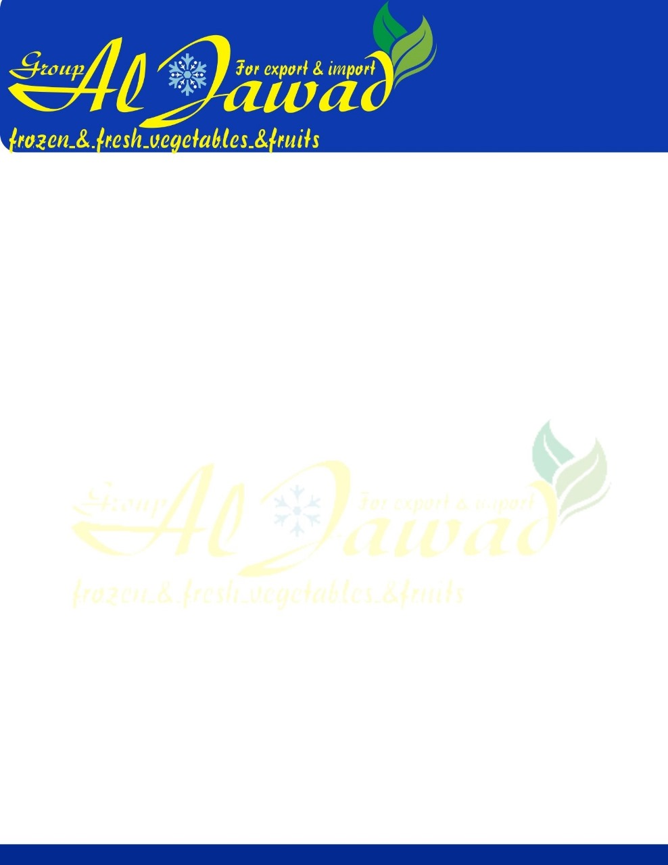

**PRODUCT DESCRIPTION:**

IQF frozen broccoli are prepared by the appropriate process from suitable variety which have been trimmed, cleaned, washed, blanched. Products are free of insect, damage, blemishes, and foreign bodies. The process ensures the stability size, color, flavor and texture. The end product temperature on transportation is not warmer than - 18ºC. The product complies in all respects with the provisions of the current Food and Drugs Administration.

**size:** 20-40 mm /40-60 mm

1. **PRODUCT COMPOSITION:** 100 % Fresh Broccoli
2. **PHYSICAL QUALITY:**

**Tolerances per 1000g**

|  |  |  |
| --- | --- | --- |
| **Criterion** | **Description** | ***20-40 mm*** |
| Foreign Material | Foreign matter includes such as wood, stones, insects, grit, etc., | *Nil* |
| E.V.M. | Any non-toxic vegetable material from the parent plant | *Nil* |
| Rotten | Pieces which are rotten | *Nil* |
| Major Blemish | Any blemished pieces showing discoloration > 6 mm | *1 pcs* |
| Minor Blemish | Any blemished pieces showing discoloration < 6 mm | *3 pcs* |
| Clumps | 3 pieces which are clustered together and cannot  be separated without causing any damage | *%2* |
| Yellowed | Yellowed florets | *%5* |
| Oversize | These are pieces which are greater than 40 mm | *%10* |
| Undersize | These are pieces which are smaller than  *20 mm* | *%5* |
| Crumble | Broken pieces of floret | *%4* |



1. **MICROBIOLOGICAL LIMITS:**

**Target Max. Limit**

|  |  |  |
| --- | --- | --- |
| *Salmonella(at 25 g)* | Absent | Absent |
| *Lysteria Mono.(at 25 g)* | Absent | Absent |
| *E.coli 0157* | Absent | Absent |

1. **PRODUCTION CONTROLS:**

|  |  |
| --- | --- |
| Metal Detection | Detector to reject test pieces “in-pack” *3,5* mm Ferrous, 4 mm Non- ferrous& 4,5 mm Stainless steel |
| Temperature Controls | Packaged end product temperature should not be warmer than –18C° |

1. **PACKAGING, LABELING, CODING AND TRACEABILITY:**

Net: 10 kg

|  |  |
| --- | --- |
| **Packing** | **Detail** |
| External Packing | Carton Box |
| Internal Packing | Blue PE Bag, Suitable for Food |

1. **Nutrition :Per 100g**

|  |  |  |  |  |  |  |
| --- | --- | --- | --- | --- | --- | --- |
| Energy | Protein | Fat | Saturated Fat | Carbohydrate | Sugar | Sodium |
| 180 kJ | 6.3g | 0.4g | 0.03g | 0.6g | 0.5g | 189mg |

1. **SHELF LIFE:** 18 months in appropriate conditions.
2. **STORAGE:** Storage at -18 °C or below

**7-DISTRIBUTION:** Goods should be loaded at -18 °C

1. **TERMS OF SERVICE:**
   1. Cold storage at -18 °C or below
   2. Don’t freeze after thawing.