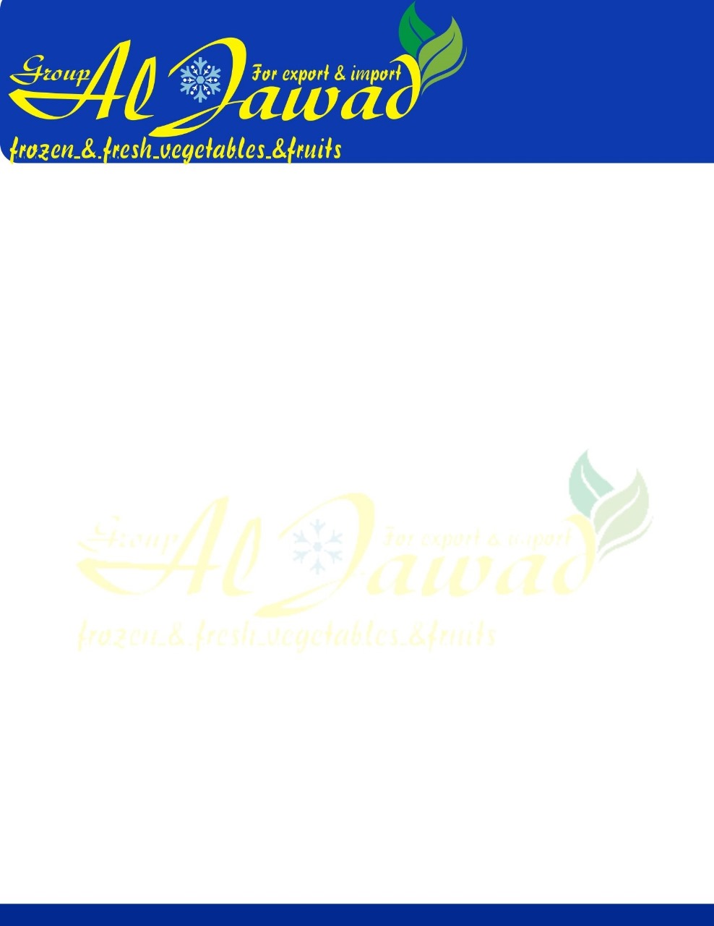

**Product Specification** / IQF Chopped Spinach (Grade A)

**Microbial Standard**

Must be met at the plant level on domestic production and at the time of entry into Your Market

in the case of imported products.

|  |  |
| --- | --- |
| **Ingredients** | Spinach. Product contains no additives or artificial preservatives. |
| **Variety** | Acceptable freezing variety and manufactured in accordance with Good M anufacturing Practices. |
| **Maturity** | Spinach has matured sufficiently to have become tender and free from any coarse or tough leaves and stems. |
| **Cut** | Spinach leaves are chopped into 10mm x 10mm, style consisting substantially of the leaf and adjoining portion of the stem that has been chopped into small pieces. (Max. 10%stem). |
| **Blanch** | Product is blanched sufficiently to inactivate the peroxidase enzyme system. |
| **Freezing Technique** | Individual Quick Frozen (IQF) |
| **Organoleptic** | Product possesses a good characteristic normal flavor, aroma, and appearance of spinach.Free from objectionable flavor and odors of any type. |
| **Color** | Product must possess a good, bright, uniform characteristic dark green color typical of young spinach. Stem part is light green in color. Maximum tolerance for color variation or seriously discolored units is 2.5% total by weight. |
| **Major Defects** | No tolerance for foreign matter such as wood, stones, glass, plastic, metal or hair. |

**Stander Packing:** 400 gm *20 bags in Total 8 kg  
 400 gm *25 bag in Total 10 kg

400 gm*62 bag in Total 25 kg

**Class Plan**

|  |  |  |  |  |
| --- | --- | --- | --- | --- |
|  | n | c | m | M |
| Total Plate Count (TPC) | 5 | 5 | 100,000 CFU/ | 250,000 CFU/g |
| Total Coliforms | 5 | 2 | 100 CFU/g | 1000 CFU/g |
| Escherichi coli | 5 | 0 | 10 CFU/g |  |
| Listeria monocytogenes | 5 | 0 | 100 CFU/g |  |
| Salmonella | 5 | 0 | Negative/25g |  |

**Note**

n = number of samples to be tested from a particular lot number.

c = maximum number of samples allowed to be between m and M.



m = microbiological limit which separates good quality from marginally acceptable quality

**Product Specification** / IQF Chopped Spinach (Grade A)

**Nutrition Facts**

The values are expressed as units per 100 grams.

|  |
| --- |
| **Nutrients per 100g** |
| Calories | 29.00 |
| Fat (g) | 0.57 |
| Saturated Fat (g) | 0.04 |
| Trans Fat (g) | 0 |
| Cholesterol (mg) | 0 |
| Sodium (mg) | 74.00 |
| Potassium (mg) | 346.00 |
| Total Carbohydrates (g) | 4.21 |
| Dietary Fiber (g) | 2.90 |
| Total Sugars (g) | 0.65 |
| Added Sugars (g) | 0 |
| Protein (g) | 3.63 |
| Vitamin C (mg) | 5.50 |
| Vitamin D (mcg) | 0 |
| Vitamin E-Alpha Toco (mg) | 2.90 |
| Calcium (mg) | 129.00 |
| Iron (mg) | 1.89 |
| Ash (g) | 1.43 |
| Water (g) | 90.17 |

|  |  |  |
| --- | --- | --- |
| **Nutrition Facts**  **Valeur nutritive**  Per 4/5 cup (85 g)  pour 4/5 tasse (85 g) | |  |
| **Calories 25** | % Daily Value*  % valeur quotidienne* | |
| Fat / Lipides 0.5 g | | 1% |
| Saturated/saturés 0 g | | 0% |
| + Trans/trans 0 g | |  |
| **Carbohydrate / Glucides 4 g** | |  |
| Fibre / Fibres 2g | | 7% |
| Sugars / Sucres 1 g | | 1 % |
| **Protein / Protéines 3 g** | |  |
| **Cholesterol / Cholestérol 0 mg** | |  |
| **Sodium 65 mg** | | 3% |
| Potassium 300 mg | | 6% |
| Calcium 100 mg | | 8% |
| Vitamin A-RAE (mcg) | | 586.30 |
| Iron/Fer 1.5 mg | | 8% |
| Vitamin A Vitamine A 500 mcg | | 56 % |
| Vitamin C / Vitamine C 4.5 mg | | 5% |
| Vitamin D (mcg) | | 0 |
| Vitamin D / Vitamine D 0 mcg | | 0% |
| *5% or less is a little, 15% or more is a lot  *5% ou moins c'est peu, 15% ou plus c'est beaucoup | |  |