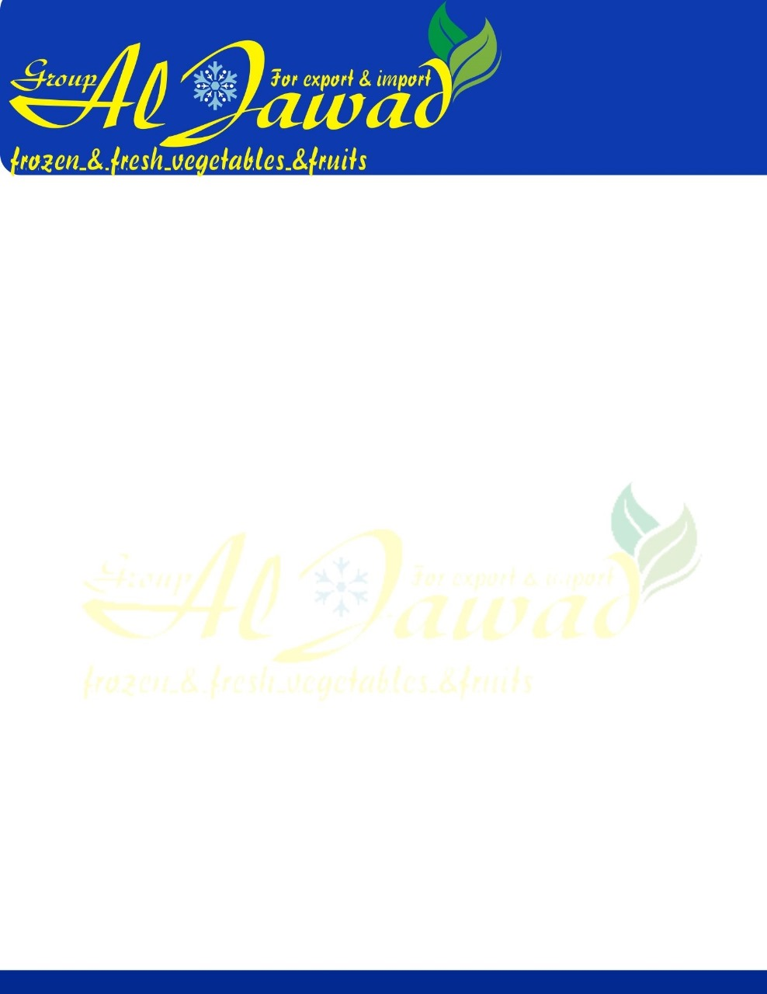

**Egyptian Fresh Artichoke**

**Specifications :**  
Fresh Artichoke Class A / French & Baladi  
Size: From 6cmup to 11cm

**Packaging :**  
Size : 6cm to 8cm - 30 pieces - 200 gram each ( standard)  
Size : 8cm to 9cm - 24 pieces - 250 gram each  
Size : 9cm to 11cm - 20 pieces - 300 gram each  
Container 40 feet Capacity - 1800 box - Total 14 Tons

SEASON DECEMBER TO APRIL

**Payment:** %50 Avance payment & %50 Final payment with copy of confirm shipping document  
**Price:** Competitive prices for all Markets

**Specification**

|  |  |
| --- | --- |
| **Fresh Artichoke Whole** | |
| Type | Vegetables |
| MOQ | 14 Tons |
| Packaging | As Per Customer Choice |
| Delivery Time | 1-2 Weeks |
| Packaging | Standard Export  Packaging / Custom As per Customer Requirement |
| Payment | T/T, LCD |
| Shipping | By Sea |