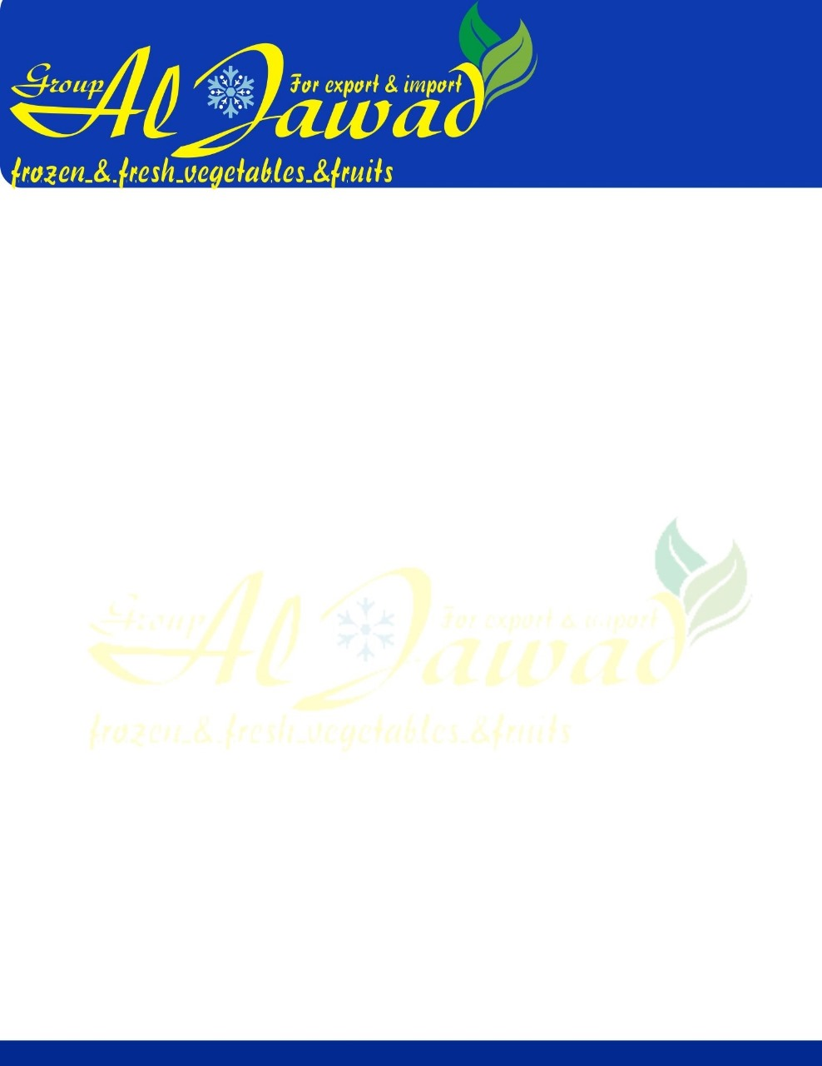

**Fresh Carrot**

**We Are Leading Egyptian Exporting Company in the field of agriculture products for 15years We Supply all kind of Fruit and Vegetables**

**We would like to Interduce Our Egyptian Carrots.**

**Specifications**

**Fresh Carrots Class A Egyptian Carrots**

**Size: Small -medium - Large**

**Packaging**

**Package  6kg - 10kg - 15kg - 25kg boxes or as customer requirements**

**Container 40 feet Capacity -2000 box - Total 17 Tons to 20 tons**

**Payment: %50 Advance & %50 Final payment with copy of confirm shipping document**

**Price: Competitive prices for all Markets**