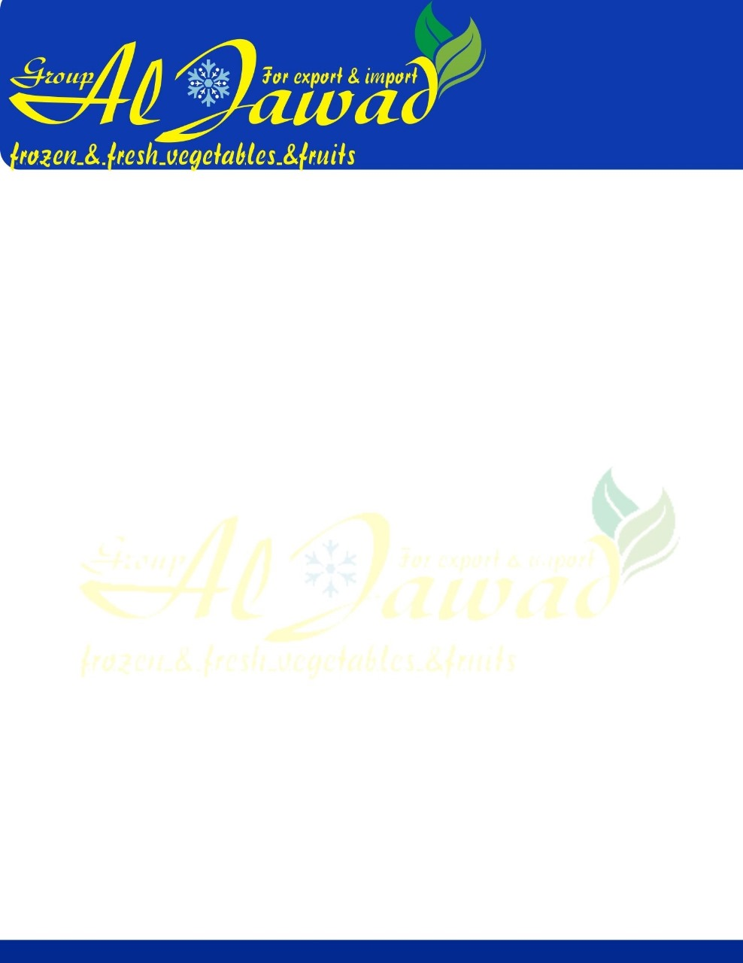

**Egyptian Mandarin Orange**

**Specifications :**

* Fresh Navel Orange Class A Egyptian VALENCIA Orange
* **Size:** 44/48/56/64/72/80/88/100/113/125
* **Color:** Orange seed
* **Shape:** Round more juicy
* **Availibilty:** DEC unti MAY

**Shipping Packaging :**

* **Package:** 15kg Carton or 7.5 kg caron or as customer requirements
* Each 1200kg on pallet (80 cartons on pallet 15 kg} & 150 cartons 8kg
* Container 40 feet Capacity 24 tons
* No of cartons per container 1600 cartons 15kg

**Payment:** %50 Avance payment & %50 Final payment with a copy of the confirmed shipping document

**Price:** Competitive prices for all Markets

**Specification**

|  |  |
| --- | --- |
| **Fresh Citrus Fruit - Orange** | |
| Type | Citrus Fruit |
| MOQ | 24 |
| Packaging | As Per Customer Choice |
| Delivery Time | 1-2 Weeks |
| Packaging | Standard Export Packaging / Custom As per Customer Requirement |
| Payment | TT |
| Shipping | By Sea |