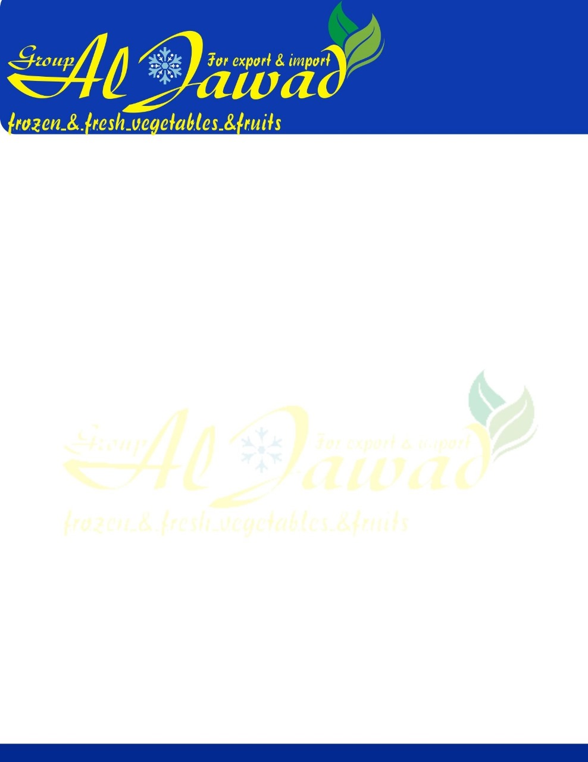

Fresh Potatoes

Wholesale price from Egypt fresh potatos

|  |  |
| --- | --- |
| **Product Type:** | Fresh  potatoes |
| **Varieties** | Spuntta , Kara , Rosetta , Nicola , Diamante |
| **Place Of Origin:** | Egypt |
| **Package:** | **25 kg \ plastic bags\ pp bags** |
| **size:** | **40 up 80 mm** |
| **Delivery Time:** | Within 7-10 days after payment |
| **Payment Terms:** | T/T, L/C, Bank account, Western Union ect. |
| **MOQ:** | 1*40' FCL |