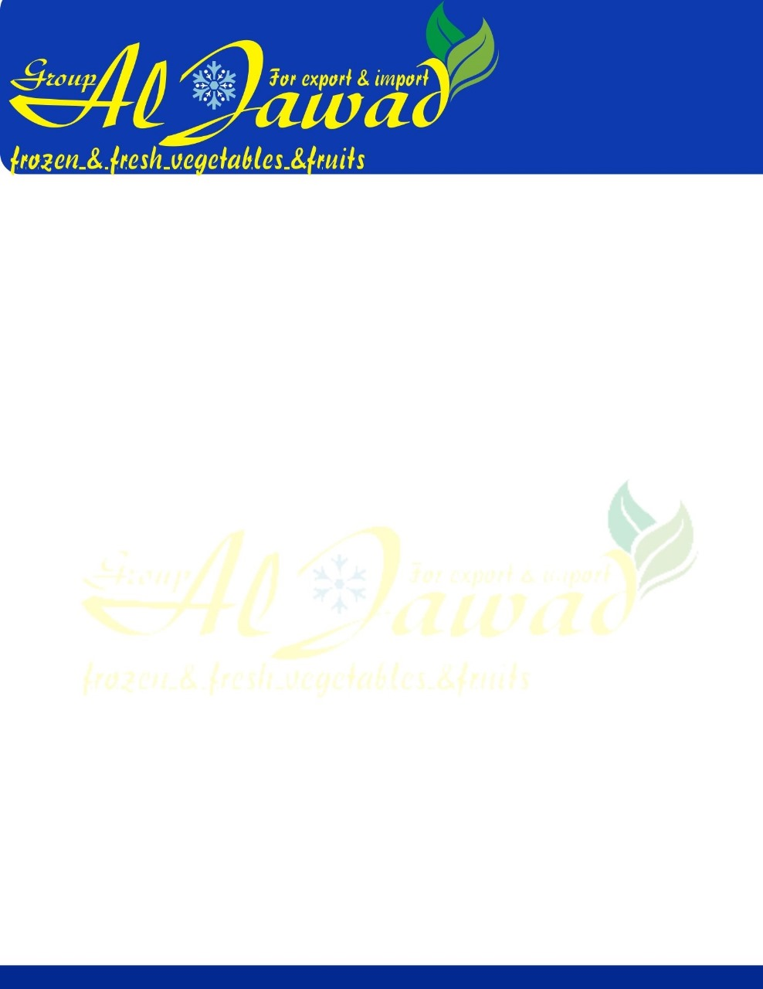

**Fresh Lemon**

**Lemon varieties available:**

**adalia , VERNA**

**Size: 80, 88, 100, 105, 113, 125, 138, 165.**

**Packing Available:**

* **Net weight 15 KG / Gross weight 16 KG**
* **Net weight 8 KG / Gross weight 8.775 KG**

**Container capacity:**

·         **Tons per container: 24 Tons.**

·         **Pallets per container: 20 pallets.**