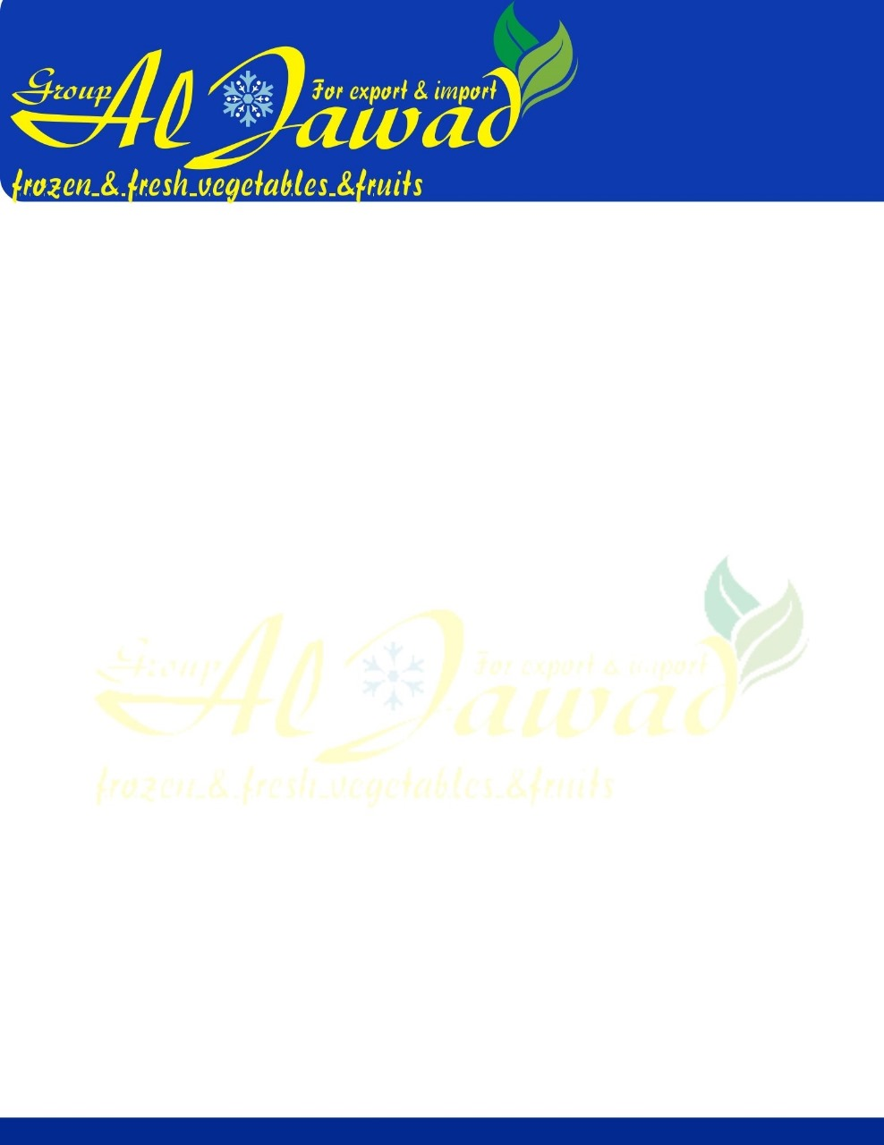

Fresh Mango

Premium Quality Best Selling Delicious Taste 100% Natural Egyptian Fresh Fruit Mangoes at Wholesale Market Price

|  |  |
| --- | --- |
| **Product Name** | Fresh Mangoes |
| **Storage Type** | Dry Cool Place |
| **Type** | Fresh Mango |
| **Product Type** | Tropical & Sub-Tropical Fruit |
| **Style** | Fresh |
| **Cultivation Type** | Organic |
| **Color** | Green - Yellow - Red |
| **Shelf Life** | 21 days |
| **Weight (kg)** | 5 kg carton or basket |
| **Instruction for use** | Food Consumption |