

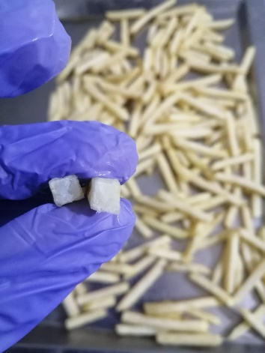

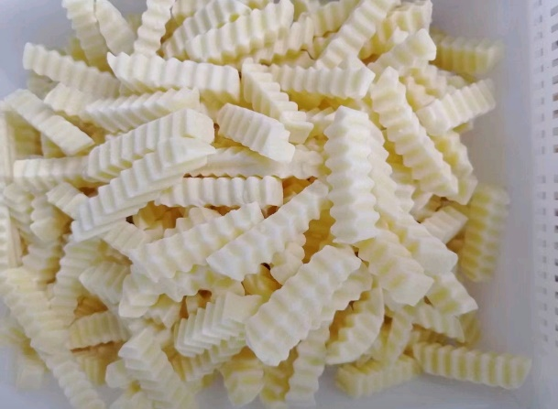

**DESCRIPTION:** Pre-fried & frozen french fries (different cut sizes)

**SHELF LIFE:** 18 months

**INGREDIENTS:** Potato (96%), sunflower oil (4%)

**ORIGIN:** The Netherlands

# PRODUCT DESCRIPTION

French Fries are produced from healthy fresh (stored) potatoes of a regular pre-graded (40+) size. The frozen product is pre-fried and has a pale yellow colour. After preparation in a deep-fryer the product is golden yellow to light brown, crusty on the outside and soft on the inside. Its distinctive taste and scent are characteristics of traditionally fried potatoes.

# PROCESS DESCRIPTION

All potatoes are sampled and inspected before they may be taken in for processing. The incoming raw material must comply with CKA-II standards and with all relevant European legislation, including pesticide regulations. In the production process the potatoes are first de-stoned and washed. After steam-peeling, brushing and rinsing off they are hydro-cut to straight strings or mechanically cut to corrugated (crinkle) strings. Significant blemishes and undersized bits are removed automatically and after that the product is blanched in hot water, pre-fried in pure vegetable oil, cooled, quick frozen and finally packed.



# AVAILABLE CUT SIZES

Straight cut 6x6mm Straight cut 7x7mm Straight cut 9x9mm Straight cut 10x10mm Straight cut 12x12mm Straight cut 14x14mm Crinkle cut 10x10mm Steakhouse cut 10x20mm

# LENGTH

## AA-grade A-grade B-grade

>75mm: target: min. 15% (w/w)

>50mm: target: min. 80% (w/w) min. 70% (w/w) min. 50% (w/w) 25-50mm: target: max. 18% (w/w) max. 27% (w/w) max. 45% (w/w)

<25mm: target: max. 2% (w/w) max. 3% (w/w) max. 5% (w/w)

# BLEMISHES (black spots)

## July-December January-June

Large (>12mm): max. 2 strings/kg max. 3 strings/kg

Medium (6-12mm): max. 5 strings/kg max. 6 strings/kg

Small (3-6mm): max. 20 strings/kg max. 20 strings/kg

# COOKING INSTRUCTIONS

DEEP FRYER

Fry small quantities in hot oil (175 degrees Celsius) for 3-5 minutes. Drain on absorbent paper before serving.

Do not eat the product after expiry date / best before end date.



|  |  |
| --- | --- |
| **7. NUTRITIONAL INFORMATION** |  |
|  | **PRE-FRIED FROZEN** |
| Energy (kj) | 582 |
| Energy (kcal) | 138 |
| Fat (g) | 4 |
| Fat Acids Saturated (g) | 0,5 |
| Carbohydrates (g) | 22 |
| Of which Sugar (g) | 0,2 |
| Protein (g) | 2,5 |
| Salt (g) | < 0,1g |
| Fibre (g) | 2,2 |

Nutritional information are average values per 100g product.

This product is free of raw materials and ingredients produced from genetically manipulated

organisms.

