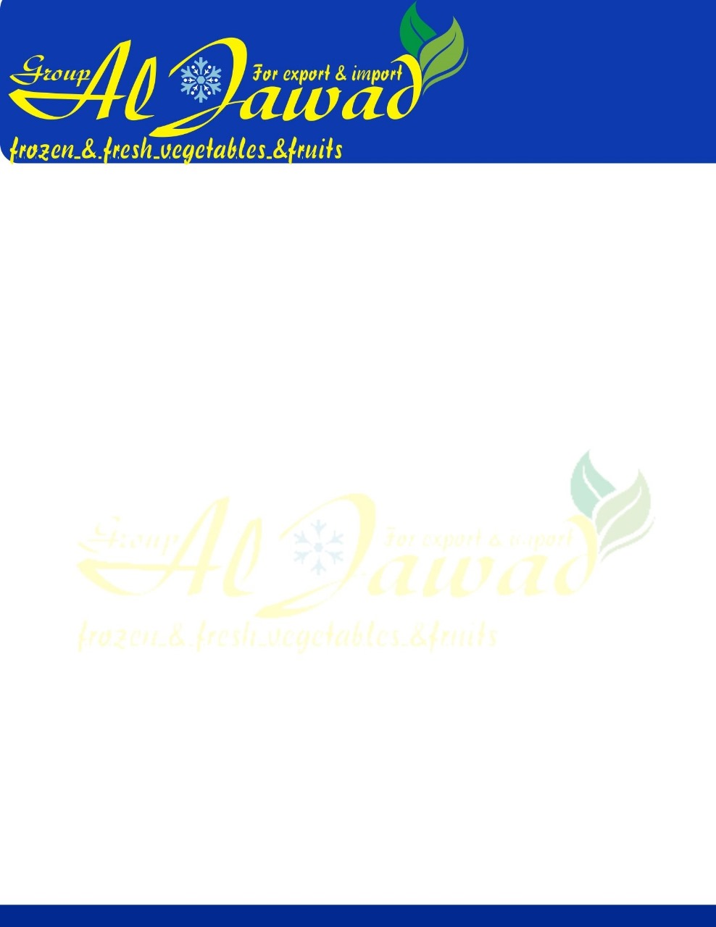

**Frozen Carrot**

**GENERAL** The product shall be prepared from fresh sound raw material that is free from all toxic residues and taints. The final product shall comply with all current Egypt

**ORIGIN** Egypt .

**INGREDIENTS** Carrots 100%

**PROCESSING** carrots are delivered fresh to the factory; each load is visually assessed for foreign material and physical defects. The load is then cleaned, peeled, diced, blanched, cooled, frozen, inspected and then filled into either 25kg sacks, 10kg cardboard cartons or bulk palletainers for further reworking if required. The pallet or palletainer is then labelled and transferred to the cold store, where they are stored at –18oc or below until required for delivery or further reworking.

**PACKING** During packing, the carrots are inspected before being filled into blue polythene lined cartons and weighed. The carton is then sealed with blue tape and inkjet printed with product description, weight, Use By and Production Date code in DD/MM/YY format, it is then metal detected, palletised and stretch wrapped before being transferred to cold store for storage.

**QUALITY CONTROL** Checks are carried out on the following: -

Processing: - Raw material

Blancher temperature Peroxidase

Cooler water temperature Magnet check

Final product testing

Packing:- Check weight Inkjet print check Metal detection

**DEFECT TOLERANCES :** Product is checked hourly against the following tolerances for

defects



|  |  |  |  |
| --- | --- | --- | --- |
| **Per 1000g**  Clumps | **A**  10 | **B**  25 | **C** |
|  |  | 25 |  |
| Foreign Material | 0 | 0 | 0 |
| E.V.M. | 0 | 1 | 2 |
| **Per250g**  Gross blemish | 0 | 0 | 1 |
| Major blemish | 1 | 3 | 6 |
| Minor Blemish | 5 | 10 | 20 |
| Greening | 5 | 10 |  |
|  |  | 20 |  |
| Oversize | 3% | 5% | 5% |
| Undersize | 5% | 10% | 15% |

## DEFENITION OF DEFECTS

### CLUMPS

These are where three or more carrots are frozen together which cannot be readily separated without causing damage to the carrot.

### FOREIGN MATERIAL

This includes any material not derived from the carrot plant or defined as EVM, such as insects, pieces of insects, wood, glass, stones, metal, sand, grit, plastic, or any other material which will render the product unacceptable.

### EXTRANEOUS VEGETABLE MATTER

This is any material other than the carrot, which is derived form the carrot plant or any other harmless vegetable matter.

### GROSS BLEMISH

A gross blemish is a black, brown or decomposed area, which covers any area greater than 25% of the surface area of the die.

### MAJOR BLEMISH

A major blemish is a discoloured area (other than green) either as a single blemish or as an aggregate of blemishes covering an area greater than 6mm diameter.



### MINOR BLEMISH

A major blemish is a discoloured area (other than green) either as a single blemish or as an aggregate of blemishes covering an area less than 6mm. Single blemishes below 2mm shall be ignored.

### GREENING

A die with greening is one, which is green for greater than half its surface area.

### OVERSIZE

Dice that are larger than one and a half times the declared size in any one or more dimension.

### UNDERSIZE

For nominal 10x10x10mm dice, this measurement should be made on a separate 250g sub sample taken from the 1000g sample used for the assessment of clumps, foreign material and extraneous vegetable matter. Undersize pieces are those, which fall through a sieve having square holes 8x8mm. The dice must be sieved in a frozen state.

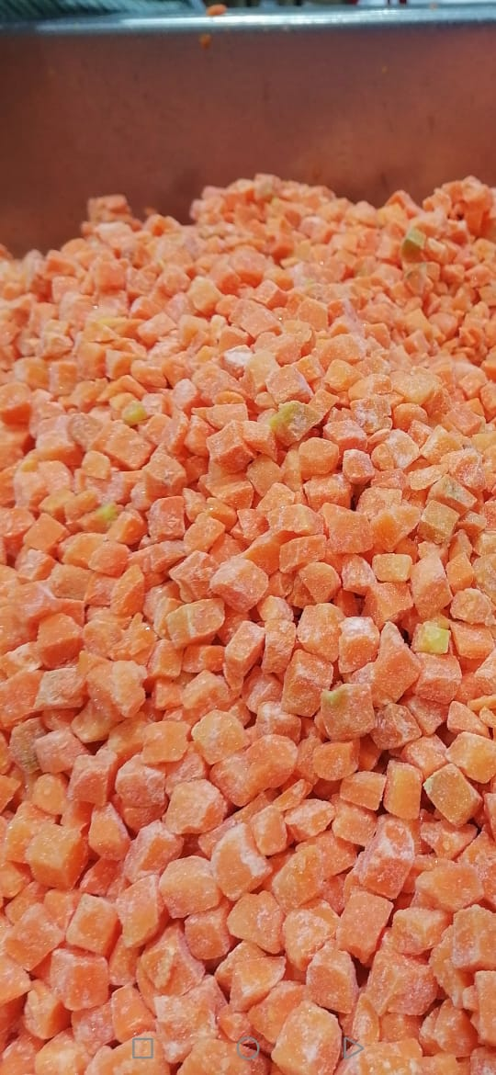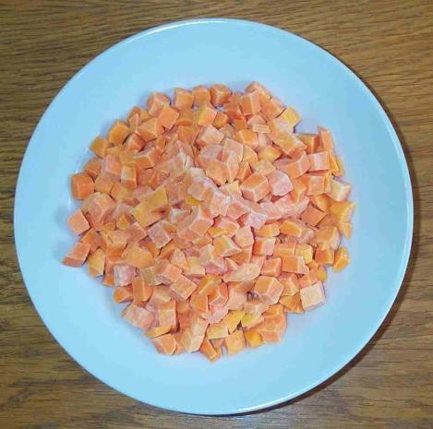

### ORGANOLEPSIS

**COLOUR**

**A:** Bright, deep orange, uniform within the sample.

**B:** Slightly lacking uniformity. May be slightly dull and/or slightly pale

**C:** Rather non-uniform. May be rather pale or rather dull.

**FLAVOUR A**: Full characteristic sweet flavour, typical of product.

**B:** Slightly weak characteristic flavour, may be slightly bitter or harsh.

**C:** Moderately weak flavour, may be moderately harsh or bitter.

**TEXTURE A:** Carrots shall be uniformly firm, but yielding to the bite, and should be free from tough cores and any fibrous or woody material.

**B:** Carrot may be slightly soft, very slightly tough or slightly fibrous, but



should be free from woodiness.

**C:** Carrot may be moderately soft, some may be moderately fibrous, but should not be woody.

### This is not a final product and will require further cooking. MICROBIOLOGICAL

|  |  |  |
| --- | --- | --- |
| **ORGANISM** | **TARGET** | **MAXIMUM** |
| T.V.C | 5X105 | 1x106 |
| ENTROBACTERIA | 5X102 | 1x103 |
| E.COLI | <40 | 1x102 |
| STAPH AUREUS | <40 | 1x102 |
| LISTERIA | Absent in 25g | 1x102 |
| SALMONELLA | Absent in 25g | Absent |
| YEASTS | 1x102 | 2x103 |
| MOULDS | 1x102 | 1.5x103 |

**ANALYTICAL** Product shall be blanched to give a trace positive peroxidase reaction between 60 and 90 seconds. Double blanched products shall have a reaction of 120+.

**WEIGHT CONTROL** The product shall be packed to a minimum weight.

**METAL DETECTION** All cartons shall be passed through a metal detector.

The testing shall be tested at least hourly using 2.0mm ferrous 2.5mm non-ferrous & 3.0mm stainless steel test pieces.



**CODING** Use by date shall be 24 months from the day of packing DD/MM/YY.

Production date & Traceability is open date code DD/MM/YY.

**CARTON LINERS** Blue food grade polythene liners 30 mu co-extruded.

**CARTONS** Corrugated fibreboard of glued construction, no metal staples to be used. Shall be sealed using blue adhesive tape.

### NUTRITIONAL INFORMATION

This data conforms to the requirements of EC Council Directive 90/496/EEC 100g of uncooked carrot typically contain: -

|  |  |  |
| --- | --- | --- |
| Parameter | Value/100g | Methodology |
| Energy – kcal | 35 | McCance & Widdowson 6th Edition |
| Energy – kj | 146 | McCance & Widdowson 6th Edition |
| Moisture | 89.8g | McCance & Widdowson 6th Edition |
| Carbohydrate | 7.9a | McCance & Widdowson 6th Edition |
| - as sugars | 7.4a | McCance & Widdowson 6th Edition |
| - as polyols | 0.0g | McCance & Widdowson 6th Edition |
| - as starch | 0.3g | McCance & Widdowson 6th Edition |
| Fat | 0.3g | McCance & Widdowson 6th Edition |
| - as saturates | 0.1g | McCance & Widdowson 6th Edition |
| - as mono unsaturates | Trace | McCance & Widdowson 6th Edition |
| - as poly unsaturates | 0.2g | McCance & Widdowson 6th Edition |
| Protein | 0.6g | McCance & Widdowson 6th Edition |
| Fibre | 2.4g | McCance & Widdowson 6th Edition |
| Sodium | 25mg | McCance & Widdowson 6th Edition |

### GMO DECLARATION

Does the product, or any of its ingredients contain any genetically

modified material (whether viable or not)? ~~YES~~ / NO

Is the product or any of its ingredients not substantially equivalent

As a consequence of the use of genetic modification? ~~YES~~ / NO

Is the product or any of its ingredients produced from, but not

containing any genetically modified material? ~~YES~~ / NO



Have genetically modified organisms been used to produce processing aids or additives used in connection with the production

of the food or any of its ingredients? ~~YES~~ / NO

Have genetically modified organisms been used to produce processing aids or additives but where such genetically modified organisms are not present in the processing aid as used in connection

with the production of the food or any of its ingredients? ~~YES~~ / NO

### FOOD INTOLERANCE

|  |  |  |
| --- | --- | --- |
| **FOOD INTOLERANCE DATA**  Does the material supplied contain any of the following? (NO) ABSENT), (YES) PRESENT | | |
| **ALLERGEN** | NO / YES | **REASON FOR PRESENCE IF YES** |
| Milk & Milk Derivatives | NO |  |
| Egg & Egg Derivatives | NO |  |
| Animal Products (*) | NO |  |
| Fish / Shellfish | NO |  |
| Cereals (**) | NO |  |
| Gluten | NO |  |
| Yeast / Yeast Extracts | NO |  |
| Soya ? Soya Derivatives | NO |  |
| Fruit & Fruit Derivatives | NO |  |
| Beef & Beef Products | NO |  |
| Pork & Pork Products | NO |  |
| Lamb & Lamb Products | NO |  |
| Poultry & Poultry Products | NO |  |
| Legumes | NO |  |
| Peanuts | NO |  |
| Sulphite > 10ppm | NO |  |
| MSG | NO |  |
| BHA / BHT | NO |  |
| Benzoates | NO |  |
| Glutamates | NO |  |
| Azo & Coal Tar Dyes | NO |  |
| Added Colour | NO |  |
| Added Flavour | NO |  |
| Preservatives | NO |  |
| Antioxidants | NO |  |
| Added Salt | NO |  |
| Nut / Nut Oil | NO |  |
| Caffeine | NO |  |
| Sesame Products | NO |  |
| Garlic | NO |  |
| Poppy Seeds | NO |  |
| Mustard | NO |  |
| Celery | NO | Celery Handled on site |
| * Including any product derived from slaughtered animals, e.g gelatine, rennet  ** Including wheat, corn, barley, rye, oats, etc. Is the material suitable for:  Vegetarians? Y / ~~N~~  Vegans? Y / ~~N~~  Kosher? ~~Y~~ / N  Halal? ~~Y~~ / N  Organic? ~~Y~~ / N | | |