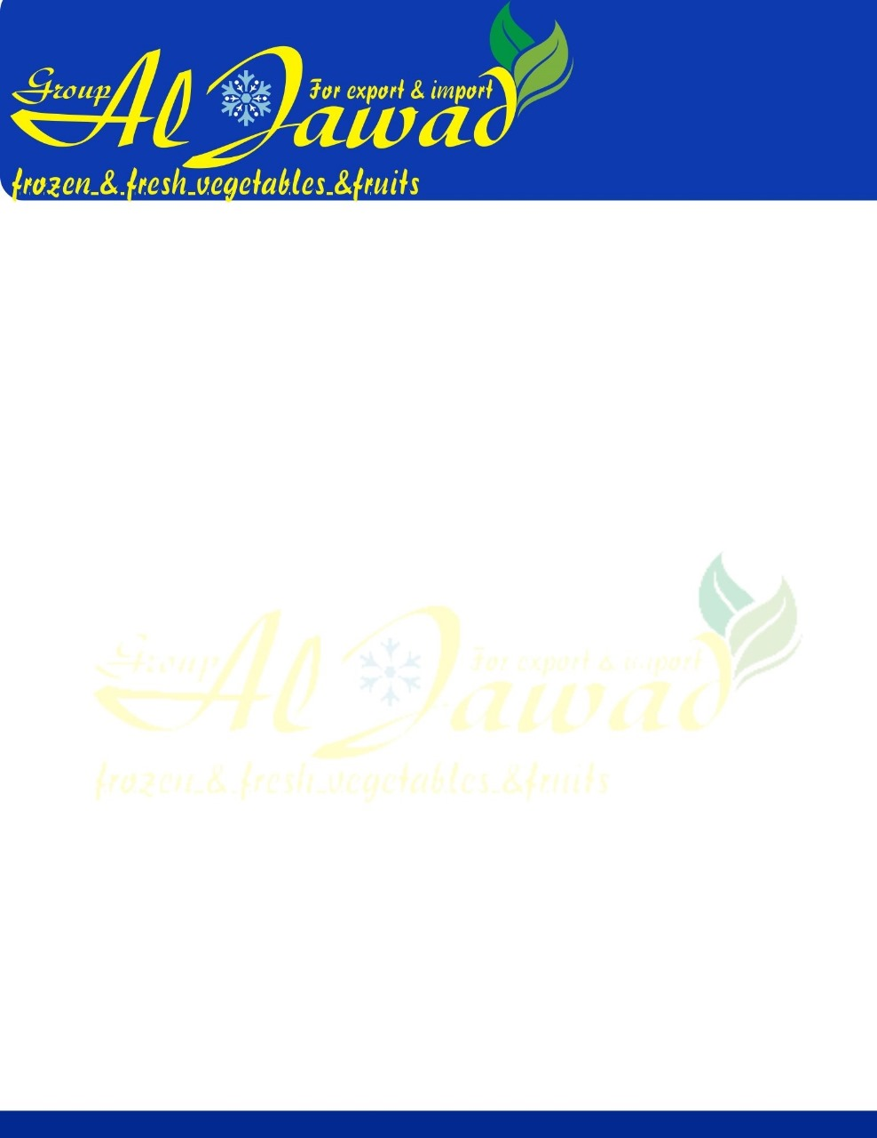

Frozen Grilled Eggplant

\*Product Description

Grilled eggplant, peeled

\* Species eggplant roomy

\* Freezing process: fast freezing

Color: Same as the natural color of eggplant

Taste: The delicious natural taste of fresh roasted eggplant with a wonderful smell of grilling

Fuel used in the grilling process: Clean natural gas leaves no residue in the final product

Storage conditions at -18 ° C

The shelf life is 18 months for the frozen and 24 months for the glass or tin can

Allowances: -

Loss of water after freezing not more than 5% max

Brown peel with a maximum of 2 \* 5 ml every 1 kg

This product does not contain allergens in accordance with EU Regulation 2011/1169 and its amendments

This product does not contain any genetically modified substances

Chemical Specifications

PH: 5-5,5

Pesticide residue complies with current limit of Eu

Packing : 2.5Kg Bags \*4

Canned : Glasses and tins