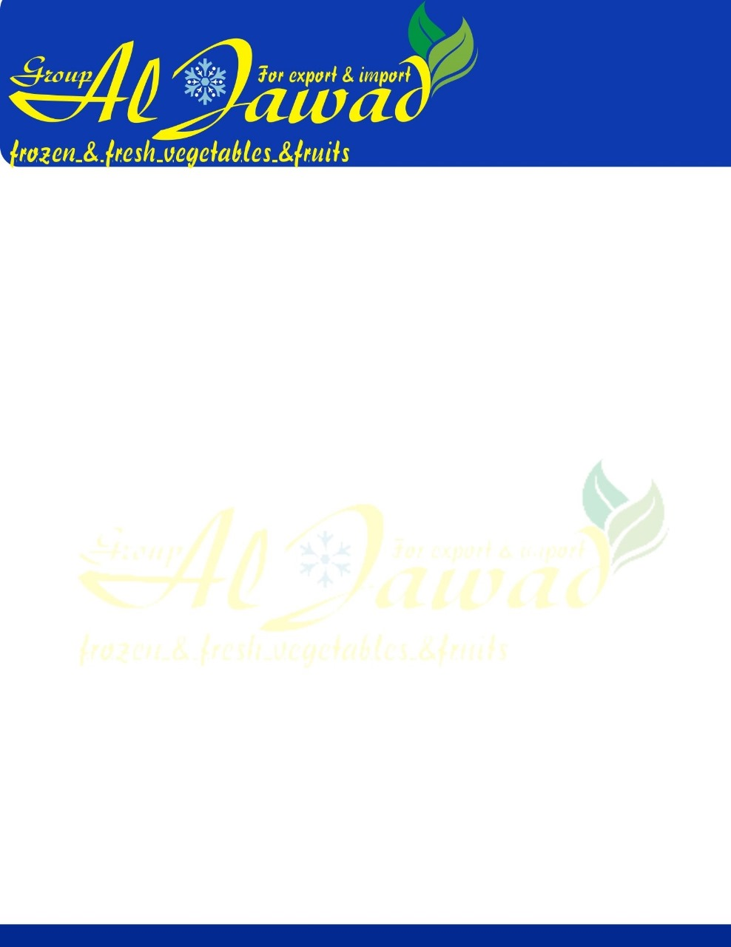

**Frozen Okra**

|  |  |  |
| --- | --- | --- |
| Frozen Okra whole Specification | **HS code :** 0710800000 | |
| **Designation:IQF Okra Ring and Whole** | | |
|  |  |  |
| **Quality description:**IQF Okra Whole, purchased from farm/market yard. The Okra are cleaned, cut and IQF at**-18°C**. Product derived from very sound and matured fruit. **GMO-** Free. **Origin:** Egypt | | |
| **Sensory evaluation:** Deep Green , typical appearance, odour and taste, firm texture | | |
| **chemical-physical and microbiological requirements** | | |
| **Analysis** | **Limits** | **Method** |
| Product size    Colour    Taste  and flavour Appearance  Blanching test  **Extraneous Matter per box** Foreign Matter (FM E.V.M Major Blemish Minor Blemish Color variants Over size Pieces Small Size Pieces  *TPC *coliforms \**E. Coli* *Yeast & Mould * *Staph. aureus* \**Salmonella* \**Listeria monocytogenes* | (0 : 2.5 & 2.5:3.5 & 3.5: 4.5 & 3.5: 5.5) cm   Deep Green  Characteristics of Okra Solid, free from foreign matter  Negative    NIL NIL 0.5 % 2% 3% ( size is <0.5mm dia ) 5% 5%    Max.10.000 CFU/g < 10 CFU/g  Absent  Max .1000 CFU/g < 10 CFU/g   Neg. in 25 g   Neg. in 25 g | Manual          Guaiacol test      Manual          IFU Method |
| **Packaging, Transport, Storage:** **Primary Packaging : 400*20bags /10** kg Carton **Transport**:        Delivery with reefer container with incoming temperatures of min. –18 °C. **Storage**:           Dry and deep-frozen at  min. –18°C **Shelf life**:           24 Month | | |
| **Availability (Crop Cycle): March to August** | | |