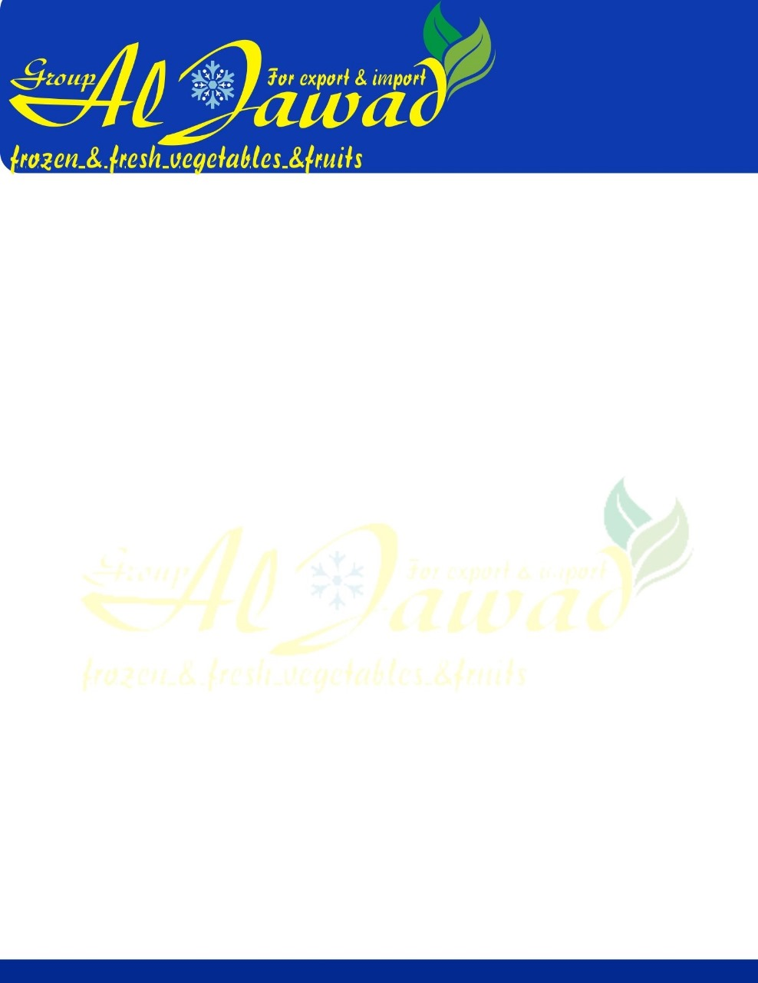

Frozen Mixed Vegetables

***INDEX OF QUALITY***

**Ingredients** Cut green beans, peas, diced carrots and corn kernels.

Product contains no additives or artificial preservatives.

**Variety** Green beans: similar shape either of the round type or flat type green beans.

Peas: possess the color and shape of one or more like varieties.

Carrots: Carrots possess the color, texture and shape of one or more like varieties Corn: Whole kernel corn of one-color variety.

**Maturity** Green beans: Beans have lost their fleshy structure; that the seeds may have passed the early stages of maturity but have not become well developed; are not fibrous; and not more than 10 per cent by count of the units show evidence of strings.

Peas: 1. When determined on the basis of tender meter test: peas fairly tender (TR <145)

2. When determined on the basis of brine flotation test: peas are in such a stage of maturity that not more than 12 per cent by count of the peas (skins removed) may sink in a solution containing 15 per cent by weight of salt.

Carrots: Product possesses a texture, typical of fresh young carrots, with units that may be somewhat firm but not fibrous.

Corn: Kernels have a fairly tender texture offering only slightly resistance when chewed.

**Cut & Ratio:** *25% Cut green beans***:** Green beans are cut uniformly into units of 1” in length. Maximum tolerance of 15% for cuts < ¾” or > 1¼”.

*25% Peas*: Uncalibrated.

*25% Diced carrots:* Carrots are peeled and trimmed and are processed through an automatic dicing machine

with a pre-set knife spacing 3/8” (not greater than 13 mm). The weight of all irregularly shaped units and splinters does not exceed 20 per cent of the weight of all units.

*\*Note: “irregular shaped units and splinters”, includes large units in excess of normal size and units not shaped in accordance with the requirements set out in the respective definition and, includes units smaller than one-half the volume of an average size cube of carrot*



*25% Corn kernels:* Kernels must be cut evenly and neatly from the cob. 90% by weight free from torn or ragged kernels.

**Blanch** Product is blanched sufficiently to inactivate the peroxidase enzyme system

**Freezing Technique** Individual quick Frozen (IQF)

**Flavor** Product, after cooking, has the flavor and odor of fairly young tender beans, peas, carrots, and corn. Free from objectionable flavor and odors of any type.

**Color** Green beans: The product possesses a color that is typical of fairly young tender green beans and are 80 per cent free from any beans which stand apart in color from the overall color appearance of the product.

Peas: Product possesses a fairly bright and fairly uniform green color. Not more than 1.0% by count of the peas may be blond or cream colored, or seriously detract from the overall color appearance of the product.

Carrots: The product possesses an orange-yellow color that is fairly uniform, and typical of

carrots of similar varietal characteristics and that not more than ten per cent, by weight in any one container may be somewhat but not distinctly different from the overall color.

Corn: The product possesses a fairly good yellow color.

Not more than 5 discolored or decayed kernels per pound (454 g).

The product shows a color typical of each vegetable. Maximum 10% by weight tolerance for discoloration.

**Major Defects** No tolerance for foreign matter such as wood, stones, glass, plastic, metal or hair.

**Minor Defects** *Cut Green Beans*

Fairly free from defects:

Combined weight of all defects or defective units does not exceed 10 per cent of the weight of all units, and that for each 10 ounces (283 g) of product there may be present

1. not more than two pieces of extraneous vegetable matter, exclusive of detached stems,
2. not more than three unstemmed units and three detached stems, or one of each, or
3. not more than 15 units damaged by mechanical or insect injury or showing rust spot blemishes;

*Peas*

Fairly free from defects:

1-In a 500g sample, there shall not be more than,

* 1. 10% by count of broken peas, split peas or loose skins
  2. 0.75% by count of blemished, discolored, spotted or stained pea