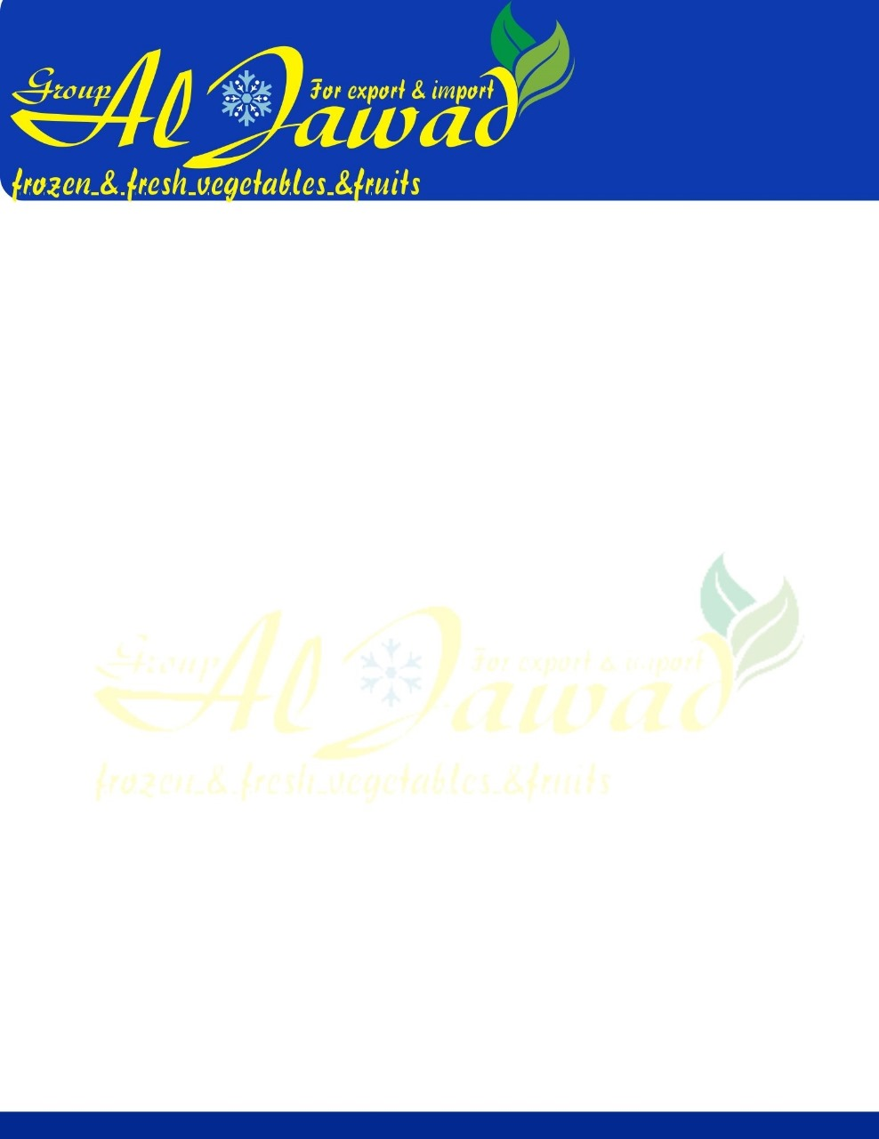

***Frozen Garlic***

**Ingredients** Garlic. Product contains no additives or artificial preservatives.

**Variety** Acceptable freezing variety and manufactured in accordance with Good Manufacturing Practices.

**Maturity** Garlic has matured sufficiently to have become full fleshed, tender yet firm.

**Cut** Garlic is processed through an automatic dicing machine with a pre-set knife spacing of 3 x 3 mm, with a tolerance of ± 1 mm.

85% must be of declared size. No peel traces are allowed in the product.

**Blanching** Product is not blanched.

**Freezing Technique** Individual Quick Frozen (IQF).

**Organoleptic** Product possesses a good characteristic normal flavor and aroma, and appearance of garlic. Free from objectionable flavor and odors of any type.

**Color** The product possesses a color that is uniformly white.

1% maximum tolerance for color variation.

**Major Defects** No tolerance for foreign matter such as wood, stones, glass, plastic, metal or hair.

**Minor Defects** Clumps which cannot be separated by hand.

**Storage & Handling** Transport and store at 0°F or colder.

**Shelf life** 24 months at 0°F or colder.

FOOD SAFETY STANDARDS

**Non-GMO** The product has not been genetically modified. It does not contain ingredients which have been genetically modified or issued from a genetically modified product.

**Pesticides** Maximum residue levels established/regulated by Health Egypt and the *Pest Control Products Act* are respected.



**Microbial Standard** Must be met at the plant level on domestic production and at the time of entry into Egypt in the case of imported products.

|  |  |  |
| --- | --- | --- |
|  | **Target (Not more than)** | **M** |
| **Total Plate Count (TPC)** | 250,000 CFU/g | 1,000,000 CFU/g |
| **Total Coliforms** | 100 | 1000 |
| ***Escherichi coli*** | 10 CFU/g |  |
| ***Listeria monocytogenes*** | Negative/25g | 100 CFU/g |
| **Salmonella** | Negative/25g |  |

M = microbiological limit which separates marginally acceptable quality from defective quality.

**Allergens** The product is free of all priority food allergens identified by Health Canada and the CFIA. The product does not contain the following:

* peanuts or its derivatives
* tree nuts or their derivatives
* sesame seeds or its derivatives
* milk or its derivatives
* eggs or its derivatives
* soy or its derivatives
* shellfish and mollusks or their derivatives
* fish or its derivatives
* wheat or its derivatives
* sulphites
* gluten
* mustard
* monosodium glutamate
* corn
* celery

An allergen control program is in practice to prevent cross-contamination of the product with allergens which may be present in other products manufactured on the same line or present in the same manufacturing plant.

**Cooking Directions** Place frozen vegetables in a small amount of boiling water. Cook until desired tenderness. Cooking time for frozen vegetables is shorter than for fresh ones, drain thoroughly, season to taste. Cooking time may vary depending on the particular appliance used.

Packing: 1*10 bags

10 Kg Bulk carton

|  |  |  |
| --- | --- | --- |
| **Packaging** | Product Code | Format |
|  | 00421 | 1 x 10 kg |
|  | 01421 | 5 x 1 kg |