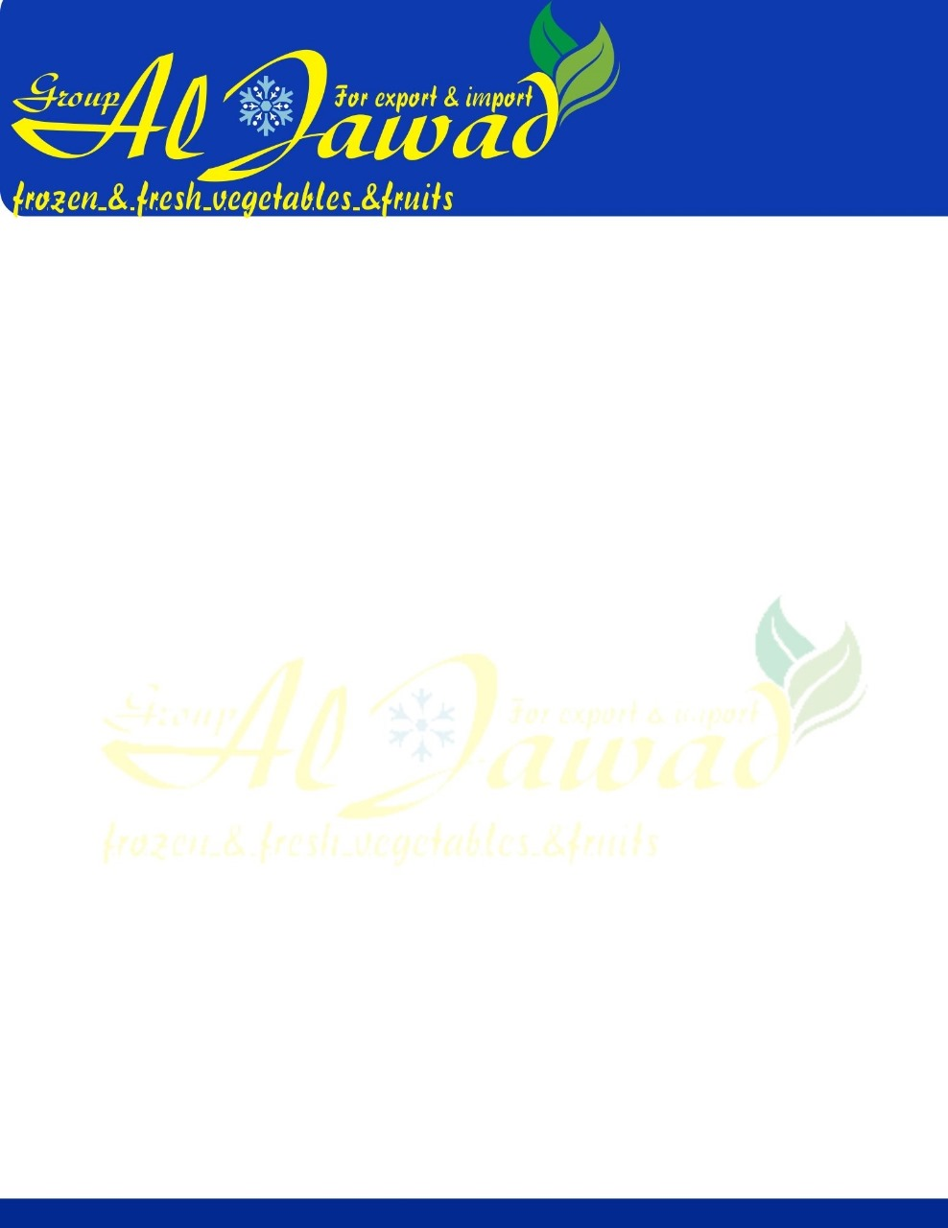

Red Onion

**Onion without roots, hairs, no worm eaten, no clay, no putrefaction.**

**Variety:   yellow onion ,red onion**

**Sizes:   (40 / 60 & 60 / 80 & 80 / 100 mm).**

**Packing:**

**25 KG mash bags.**

**10 KG mash bags.**

**Shipping:**

**a container 40 ft takes 29 TON.**