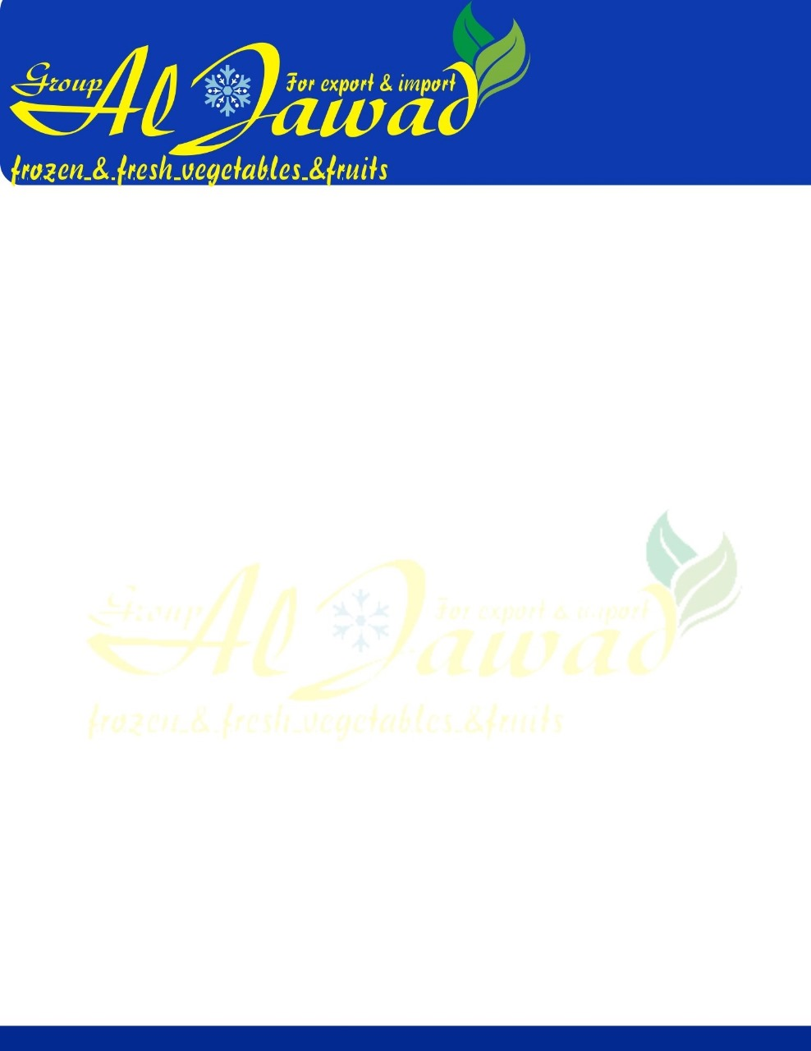

**Red and white garlic**

**Sizes:** 3-4cm, 4cm, 5cm, 5.5cm, 6cm, 6.5cm and up to 8 cm   
**Packing:**

* 5 kg   -  10kg Mesh bags and   carton box
* or as customer request
* Container 40 FT take 25 Ton   and according packing

**Availability:**

**all the year**

20000 MT/year   
**Inspection:**

Quality, quantity and weight by SGS at port of loading is Final at sellers expense

**Price:**  Very Competitive Price

**Delivery Terms:** FOB, CNF, CIF  
**Term payment:** TT, LC  
**Delivery Time**: 7 days