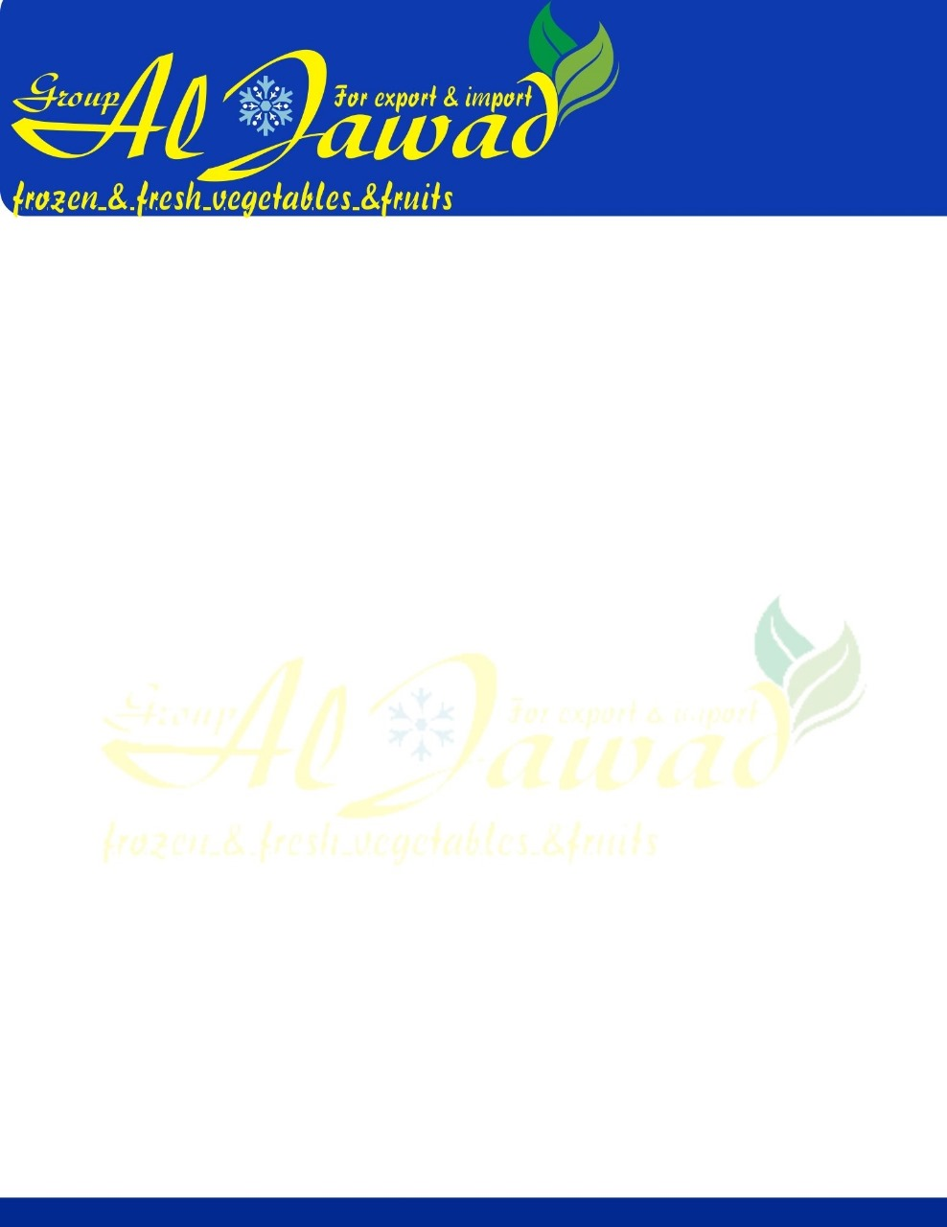

Yellow Onion

|  |  |
| --- | --- |
| **Product Name** | Fresh Red Onion, Yellow Onion |
| **Varieties** | un-peeled onion |
| peeled onion |
| **Sizes** | 3-5cm, 5-7cm, 6-8cm, 8-10cm, 10cm up |
| **Shape** | Round/Oval |
| **Supplying Period** | All the year round |
|  |
| **Transporting Temperature** | -1 ℃ - 0 ℃ |  |
| **Capacity** | Cartons packing: 26 tons for 40'rh Bags packing: 28 tons for 40'rh |  |
| **Supply ability** | 10000 tons per month |  |
| **Delivery time** | Within 7 days after receiving the down payment |  |