

***Frozen Onion***

***INDEX OF QUALITY***

**Ingredients** White onions. Product contains no additives or artificial preservatives.

**Variety** Acceptable freezing variety and manufactured in accordance with Good Manufacturing Practices.

**Maturity** Onions have matured sufficiently to have become full fleshed, tender, yet firm.

**Cut** The onions are butt-ended, peeled, and processed through an automatic dicing machine with a pre-set knife spacing 10mm x 10mm with 10% of tolerance

**Blanching** Product is not blanched.

**Freezing Technique** Individual Quick Frozen (IQF).

**Organoleptic** Product possesses a good characteristic normal flavor and aroma, and appearance of onions. Free from objectionable flavor and odors of any type.

**Color** The onions contain a characteristic white transparent color, typical of fresh onions.

**Major Defects** No tolerance for foreign matter such as wood, stones, glass, plastic, metal or hair.

**Minor Defects** Total defect will not exceed 5% by weight of defective units such as discolored units tough, woody or fibrous units.

* Maximum 2 pieces of skin/500 grams.
* No grit or slit is present in any way that might affect the appearance or taste of the product.

**Storage & Handling** Transport and store at 0°F or colder.

**Shelf life** 24 months at 0°F or colder.

FOOD SAFETY STANDARDS

**HACCP** Required

**Non-GMO** The product has not been genetically modified. It does not contain ingredients which have been genetically modified or issued from a genetically modified product.

**Pesticides** Maximum residue levels established/regulated by Health Canada and the *Pest Control Products Act* are respected.



**Microbial Standard** Must be met at the plant level on domestic production and at the time of entry into Canada in the case of imported products.

|  |  |  |
| --- | --- | --- |
|  | **Target** | **Maximum** |
| **Total Plate Count (TPC)** | Less than 250,000 CFU/g | Less than1.000,000 CFU/g |
| ***Escherichi coli*** | Less than 10 CFU/g | Less than 100 CFU/g |
| ***Listeria monocytogenes*** | Negative/25g | Less than 100 CFU/g |
| **Salmonella** | Negative/25g | Negative/25g |

**Allergens** The product is free of all priority food allergens identified by Health Canada and the CFIA. The product does not contain the following:

* peanuts or its derivatives
* tree nuts or their derivatives
* sesame seeds or its derivatives
* milk or its derivatives
* eggs or its derivatives
* soy or its derivatives
* shellfish and mollusks or their derivatives
* fish or its derivatives
* wheat or its derivatives
* sulphites
* gluten
* mustard
* monosodium glutamate
* corn
* celery

An allergen control program is in practice to prevent cross-contamination of the product with allergens which may be present in other products manufactured on the same line or present in the same manufacturing plant.



**Nutrition Facts** The values are expressed as units per 100 grams (approx. 3.5 oz serving). These

values are calculated using average USDA data. Actual analysis of different lots may vary.

**Cooking Directions** Place frozen vegetables in a small amount of boiling water. Cook until desired tenderness. Cooking time for frozen vegetables is shorter than for fresh ones, drain thoroughly, season to taste. Cooking time may vary depending on the particular appliance used.

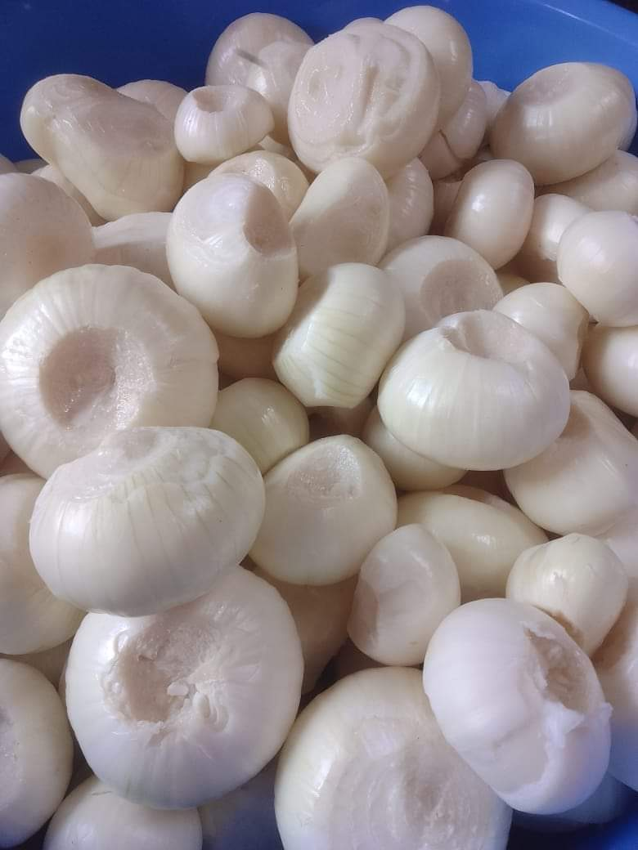

|  |
| --- |
| **Packaging** |
|  |
| 1 bag * 10KG |
| **Picture** : |
|  |