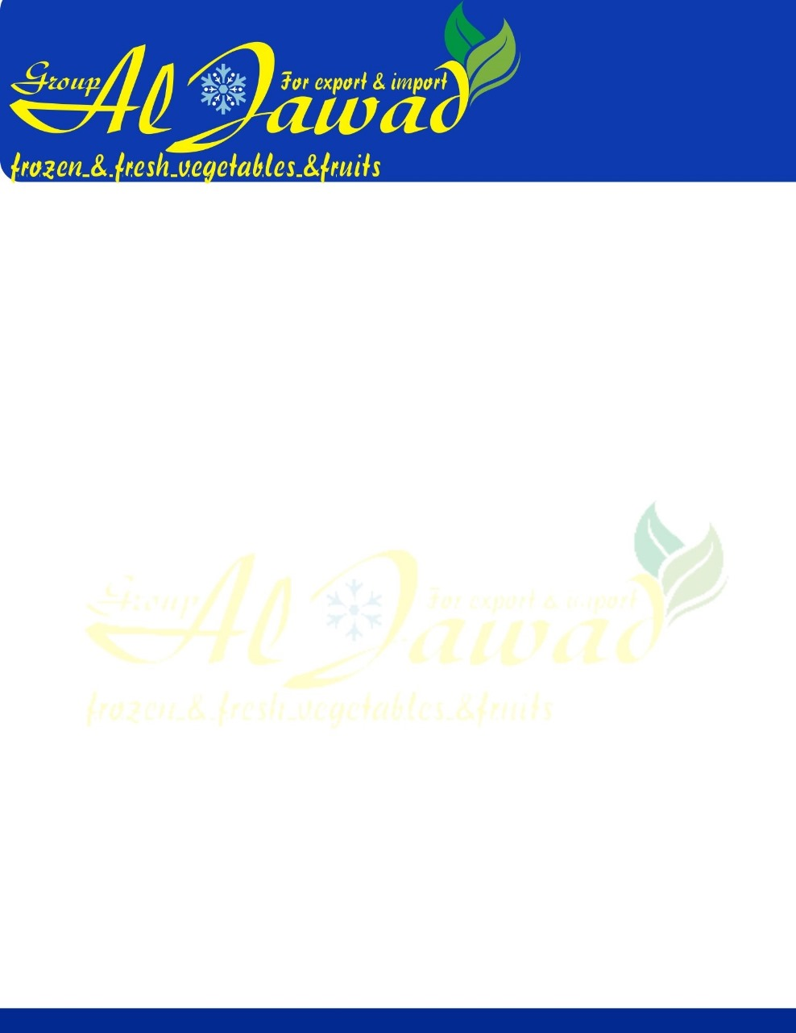

Broad Beans

### RAW MATERIAL

The mixed vegetables shall be produced from fresh sound vegetables. The process shall ensure stability of colour and flavour and the product temperature shall not be warmer than -18c when frozen.

### DEFINITION OF DEFECTS

This includes any material not derived from the product plant or defined as EVM such as insects, wood, glass, metal, snails, slugs or any other material which may render the final product unacceptable.

#### Extraneous Vegetable Matter

This includes any vegetable matter other than the product which is derived from the product plant.

#### Major Blemish

A discoloured area either as a single blemish or aggregate of blemishes covering an area of more than 6mm in diameter.

#### Minor Blemish

A discoloured area either as a single blemish or aggregate of blemishes covering an area of between 2mm and 6mm in diameter.

#### Ingredients

Products included in the mix can be all of, or a variety of, the following: Peas, Carrots, Sweetcorn, Cut Beans and Broad Beans.

The mix ratio and content to be agreed at the time of purchase.

### 

### TOLERANCE OF DEFECTS

Assessed on 1000gms

Defects Tolerances

FM 0

EVM 1

Assessed on 250gms

Major Blemish 3

Minor Blemish 10

### ORGANOLEPTIC STANDARDS

Colour Bright, Uniform and typically characteristic of the product. Flavour Fully sweet and Characteristic, typical of each product.

Texture Uniformly firm and free from woody or fibrous material. NB: THIS IS NOT A FINAL PRODUCT AND REQUIRES FURTHER COOKING

|  |  |  |
| --- | --- | --- |
| MICROBIOLOGICAL STANDARDS | m | M |
| TVC/g | 5 x 10 5 | 1 x 10 6 |
| Coliforms/g | 5 x 10 2 | 1 x 10 3 |
| E Coli/g | <40 | 1 x 10 2 |
| Staph aureus/g | <40 | 1 x 10 2 |

Salmonella/g Absent in 25g

Listeria Absent in 25g 1 x 102

### NUTRITIONAL INFORMATION

Per 100gms of Raw Product, frozen, boiled and in salted water (Reference McCance & Widdowsons 6th Edition)

KJ 180

K/Cal 42

Dietry Fibre (NSP) N

Protein 3.3

Moisture 85.8

Fat 0.5

Sat Fat N

Poly Unsaturated Fat N

Mono Unsaturated Fat N

Cholesterol 0

Starch 3.0

Carbohydrates 6.6

Sugar 3.6

Salt 96

##### THIS IS A NUT FREE PRODUCT. THE PRODUCT DOES NOT CONTAIN OR HAS BEEN

##### 

##### PROCESSED WITH ANY GENETICALLY MODIFIED MATERIALS.

##### The materials identified below are considered to be allergens. This product is completely allergen free.

|  |  |  |  |
| --- | --- | --- | --- |
| **Ground Nut** | **Hazelnut** | **Macadamia Nut** | **Pine Nut** |
| **Pistachio Nut Peanut** | **Walnut Celery** | **Cob Nut Soya Beans** | **Sesame Seeds** |

The Company Allergen Policy (Q361) is sent out to all suppliers and requires that they inform us if any of the above allergens have been used in the process, or any derivatives of these allergens have been in contact with the product supplied.

### METAL DETECTION

All packed product are metal detected using systems operating to tolerances between:

3.5mm – Ferrous – 3.5mm Non Ferrous 4.0mm Stainless Depending on the pack size.

### PACKAGING

The product shall be stored at a temperature no warmer than –18c with a recommended shelf life of 24 months.

The Label to Identify:

Supplier Commodity Net Weight Date Packed

Best Before Date

### LEGAL REQUIREMENTS

The product must comply in all respects with the provision of the current Egypt Legislation and EC Regulations, and in other respects with any applicable Codes of Practice.