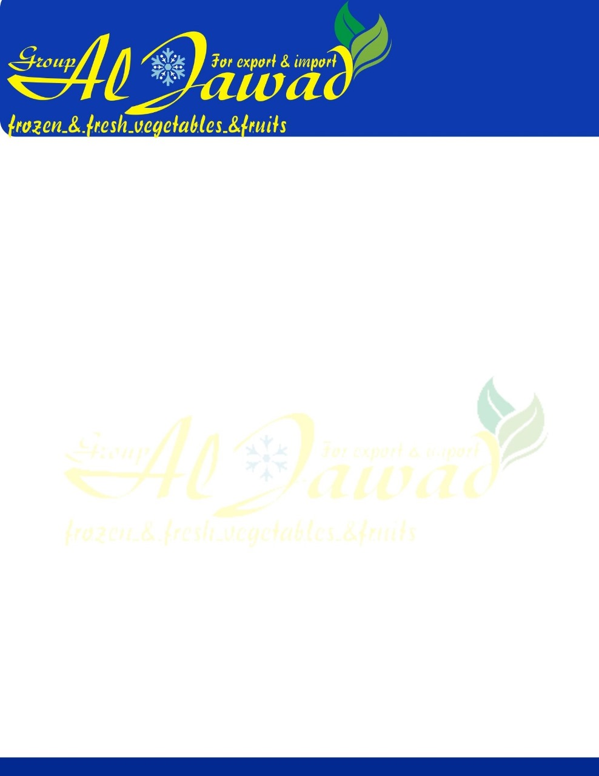

Specification: IQF Green Peas

|  |  |  |
| --- | --- | --- |
| **Quality description:**IQF Green Pea, purchased from farm/market yard.  The peas are cleaned, Deppoded and IQF at -18°C.  Product derived from very sound and matured fruit. **GMO-** Free. **Origin:** Egypt | | |
| **Sensory evaluation:** Deep Green, typical appearance, odour and taste, firm texture | | |
| **chemical-physical and microbiological requirements** | | |
| **Analysis** | **Limits** | **Method** |
| Product size    Colour    Taste  and flavour Appearance    Blanching test      **Extraneous Matter per box** Foreign Matter (FM E.V.M Major Blemish Minor Blemish Color variants Over size Pieces Small Size Pieces    *TPC *coliforms \**E. Coli* *Yeast & Mould * *Staph. aureus* \**Salmonella* \**Listeria monocytogenes* | 7-11 mm.     Deep Green    Characteristics of Green Pea Solid, free from foreign matter    Negative      NIL NIL 0.5 % 2% 3% ( size is <0.5mm dia ) 5% 5%    Max.40.000 CFU/g < 10 CFU/g  Absent  Max .4000 CFU/g < 10 CFU/g   Neg. in 25 g   Neg. in 25 g | Manual            Guaiacol test          Manual          IFU Method |
|  |  |  |
| **Packaging, Transport, Storage:** **Packaging:**       25kg Bag  with blue inner  LDPE-bags, not perforated / 10Kg Bulk carton **Transport:**        Delivery with reefer container with incoming temperatures of min. –18 °C. **Storage:**           Dry and deep-frozen at  min. –18°C **Shelf life**:           24 Month | | |
| **Availability (Crop Cycle): December to March** | | |

**Nutrition Facts**

The values are expressed as units per 100 grams.

|  |  |
| --- | --- |
| **Nutrition Facts** |  |
| per 100G Serving |  |
| **Fat** | **0.02 G** |
| **Carbohydrate** | **6.5 G** |
| **Fiber** | **1.03 G** |
| **Protein** | **1.7 G** |
| **Sodium** | **45 MG** |
| **Calcium** | **115 MG** |
| **Iron** | **1.9 MG** |
| **Vitamin C** | **16 MG** |
| **Vitamin A** | **12500iu** |