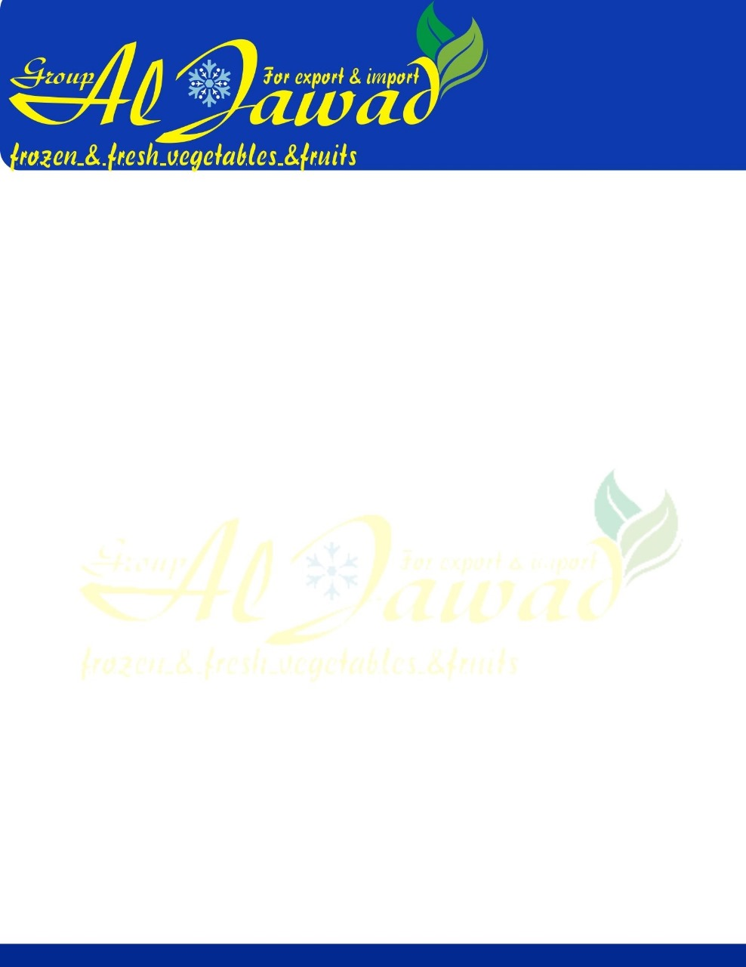

White Beans

**We would like to present our new White Kidney Beans crops with the following specifications:**

**Origin:  Egypt**

**Variety: White Kidney Beans**

**Quality: grade A**

**Specification:**

**- Moisture: 14% Max**

**-Admixture: 0.5% Max**

**- Imperfect: 2%**

**Sizes**

**1-180-200  grains per 100 gm**

**2-200-350 grains per 100 gm**

**Packing available:  25 KG, 50 kg in mesh. Bags.**

**Shipping: 20 feet dry container takes 20-25 MT.**

If you are interesting, pls contact me.

 Online Service Within 24 hours!