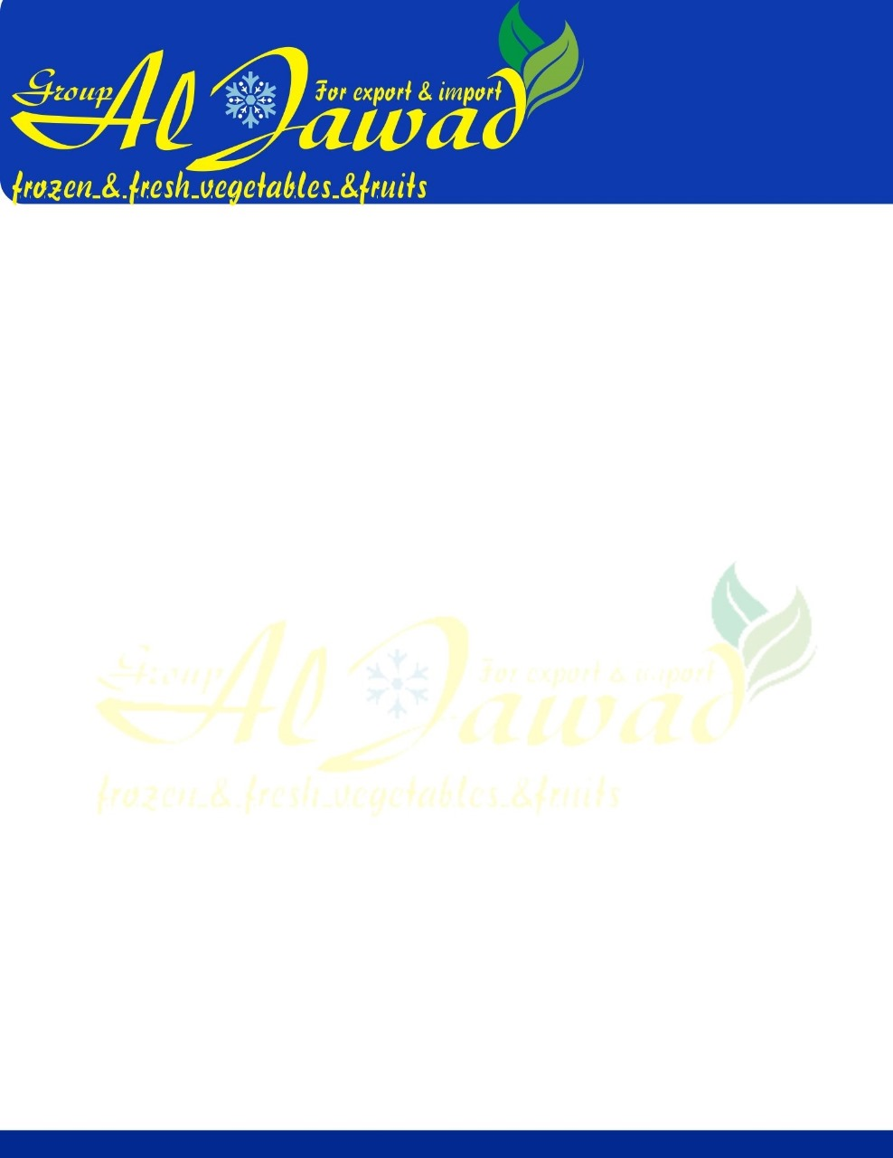

IQF Guava Dices

We export IQF guava dices available in various size and shapes made from fresh guava that is procured from finest farmlands. Fresh guavas are then washed, blanched, diced and individually quick frozen by keeping them at a temperature of -18° C.

Single Strength Specification

|  |  |
| --- | --- |
| **PARAMETERS** | **VALUE** |
| Ingredients | White / Pink Guava |
| Type | Dices/Slices |
| Origin | Egypt |
| Storage | Min -18° C |
| Shelf Life | 2 years |
| Harvesting | December – April |
| Brix corrected at 20° C (o B) | > 6.0 |
| Colour | Natural of the Fruit |
| Flavour / Aroma | Characteristic |
| Microbiological Analysis |  |
| TPC cfu/gm | < 40,000 |
| Yeast/Mould cfu/gm | < 1000 |
| Coli forms cfu/gm | < 100 |
| E-Coli cfu/gm | < 10 |
| Salmonella cfu/gm | Negative in 25g |
| Staphylococcus aureus | Negative in 25g |
| 10 Kg LDPE Bags in 5 ply Carton Box |  |
| Net Weight | 10 Kgs |
| Cases Per FCL | 2300 |

